**GRADUATE DIRECTED PROJECT**

**Project Name:** Theatre Northwest

**Team Name:** Team Sparklers

**Team Members:**

Santhosh Bonala

Saivarun Illendula

Rahul Reddy Lankala

Ashwith Gundu

Keerthi Chiduruppa

Supraja Kumbam

**Table of Contents**

1. **Introduction 3-4** 
   1. Problem Statement 3
   2. Proposed Solution 3
2. **Requirements 4-6**

2.1 Functional Requirements 4

2.2 Non-Functional Requirements 6

**3. Software Engineering Methodologies 7**

3.1 Brain Storming 7

3.2 Prototyping 7

3.3 Interviewing 7

**4. Database Design 8**

4.1 ER-Diagram 8

**5. System Requirements 8**

**6. Tools and Technologies 9-25**

**7. Developer Manual 26-32**

7.1 How to Execute the project 26

**8. Problems Faced 33-35**

**9. Test Cases 36**

**10. Incomplete Functionalities 37**

**11. User Manual 37-50**

1. **Introduction**

**1.1 Problem Statement**

According to the client, ticket booking for the shows played in the Ron Houston Center is being done manually since many days. In this process, the client had a link in the northwest site for the booking of the tickets. When a user wants to book a ticket, he/she needs to fill in the google form that is present in the link and then submit it to the Ron Houston center. Once the forms are received, client would take all the details of the user and categorize them according to the kind of user, i.e., either theatre appreciation students or anyone from the Maryville community, the number of tickets and the email of the user. All these details of the user would be filled in the excel worksheets manually by the client. This would result in hurdles of work for the client, which also includes writing of the confirmation and remainder mails to the user manually. Looking into these issues being faced by the client, a web application shall tend to solve this problem.

**1.2 Proposed Solution**

To reduce the issues that the client is facing, we have come up with a solution of developing a web application for the theatre naming it “Theatre Northwest”. This application consists of both user and admin views.

Admin dashboard - The admin needs to login in-order to add, edit or delete any shows. All these shows shall be displayed in the form of flash cards on the dashboard. Once the admin adds show and its details, he can either save it or publish it. If there are multiple dates and show timings, the admin shall add the dates by using the multiple date picker functionality in the update option of the show. After all the editing is done by the admin, he can view the audience dashboard by going to the link provided to the audience. Once the user books a ticket for the show, an automatic confirmation mail sent to the user on the name of the theatre. The admin shall be able to add new sections into the sections list of the fine art students (i.e., theatre appreciation students). The reports will be automatically updated in the excel workbook. The theatre appreciation students and the normal audience will be categorized in the workbook into two different worksheets. In case of any updates for the show, an email regarding the update will be sent to the user. Also, a remainder email shall be sent to the user on the day before the play. Besides all these, the existing admin can add new admins into the list, by choosing the add-admin functionality.

Audience dashboard - When the user visits the website, a dashboard displaying all the shows shall appear. When the user selects a show to book the tickets, he will be asked to enter his details like the first name, last name, email, and whether the user is a theatre appreciation student or a normal audience. If the user is a theatre appreciation student, he can select the section he is currently enrolled into, by looking in the section list provided. Then the user can choose the number of tickets that has to be booked. When the user confirms his booking, he will receive an automated email from the theatre. The user can get the exact address to the theatre by looking into the location added into the maps. This application shall be helpful for both the admin and the user.

1. **Requirements**

**2.1 Functional requirements**

**Audience:**

1. The web application should be able to book the show tickets for the entire Maryville Community.
2. The homepage should include all the shows with the below mentioned details:
   1. Title with picture
   2. Description of the show
   3. Date of the show
   4. Time of the show
   5. Ticket price
   6. Available Tickets
   7. Book Tickets
3. There should be a search functionality for the audience to look for a show.
4. The web application should be able to request the following information from regular audience while booking the tickets:
   1. First Name
   2. Last Name
   3. Email-ID
   4. Show Date
   5. Show time
   6. Number of Tickets
5. The web application should be able to request the following information from Theatre Appreciation Students while booking the tickets:
   1. First Name
   2. Last Name
   3. Email-ID
   4. Section enrolled
   5. Show date
   6. Show time
   7. Number of Tickets
6. The audience should be able to edit the time and date of their reserved ticket.
7. The application should be able to restrict the Theatre Appreciation students from booking no more than 1 ticket.
8. The description of the show must be a modal which displays details regarding the show and should be placed at the bottom row.
   1. This modal must include a link to the playwright.

**Administrator:**

1. The web application should allow the administrator to login using his Email address and password.
2. The dashboard should include all the shows with the below mentioned details:
   1. Title
   2. Description of the show
   3. Date of the show
   4. Time of the show
   5. Tickets Sold
   6. Tickets Available
3. The web application should allow the administrator to make necessary changes like,
   1. Add new shows.
   2. Modify details of the existing shows like:
      1. Date of the show
      2. Time of the show
      3. Adjust and reserve the number of available tickets to the user.
   3. Add an audience member to the show manually.
   4. Extend the time for ticket reservation.
4. The web application should allow the publishing and un-publishing of the shows by the administrator.
5. The application should allow the editing of user’s ticket by the administrator.
6. This application should allow an administrator to add another administrator.
7. Administrator should have the flexibility to delete the information of the completed shows.
8. The application should have a pre-generated template for the Email.
9. The application should be able to request the name of the Playwright from the administrator when adding a new show.
10. In the Cancel Ticket Page, admin should be able to change the details of whom to contact in case the audience request for cancellation of their tickets.
11. In the admin dashboard, the application should include a duplicate button to generate a similar show card where the admin can make minor changes to the details.
12. Report generation for each show should be segregated according to each section (For Theatre appreciation students).
    1. **Non-Functional requirements**

**Audience:**

1. This web application should restrict the audience to book no more than 10 tickets/user.
2. In case the user wants to book more than 10 tickets, user receives a notification with the contact details of the administrator like:
   1. Email address of the administrator.
   2. Contact Number.
3. If the show is completely booked, user receives a feedback message saying that the show is sold out and including the contact details of the administrator like:
   1. Email address of the administrator.
   2. Contact Number.
4. This web application should be able to show a feedback message to the user after he/she successfully books the tickets with the following details:
   1. Successful reservation of the tickets.
   2. An email has been sent to the mentioned email address.
5. A confirmation email should be sent to the user after the he reserves his tickets shall include:
   1. An appropriate subject line to the email.
   2. An appropriate logo.
   3. In case the audience wants to cancel their tickets, they can reply to the same email.
6. The application should allow the editing of the audience’s ticket.
7. The application should be able to send notifications or alerts when a user uses the same Email for booking tickets for the show.
8. This web application should send some reminder email 1-2 days prior to the user registered show including details like:
   1. Subject Line(Reminder)
   2. You have reserved your ticket for a show including the date and time.

**Administrator:**

1. Admin needs to fill all the required fields in the form while
   1. Adding a show
   2. Adding another admin
   3. Adding a section
2. While adding a section, year of the section should be greater than or equal to current year.
3. Admin should not be able to delete all the admins. At least one admin should be there at any time.
4. Password should meet certain criteria- needs to have one capital letter, one small letter, a special character and a number.
5. **Software Engineering Methodologies**

**3.1 Brainstorming:**

We contributed our ideas by involving several brainstorming sessions. We prioritized the ideas gathered from all the team members depending on what is the best solution for a specific problem or requirement.

**3.2 Interviewing:**

We had face-to-face interactions with our client for gathering all our project requirements. We prepared our questions to be asked to our client ahead of time and recorded the responses after every interview. This helped us in gathering valuable information from our client and to further collect for more details using follow up questions.

**3.3 Prototyping:**

We used prototyping for idea verification and further analysis. We used an iterative process of prototype creation, testing and feedback before reaching the final stage of the project. This allowed our client to instantly see the outcome of his requirements and change some of their requirements.

1. **Database Design**

**4.1 ER-Diagram:**

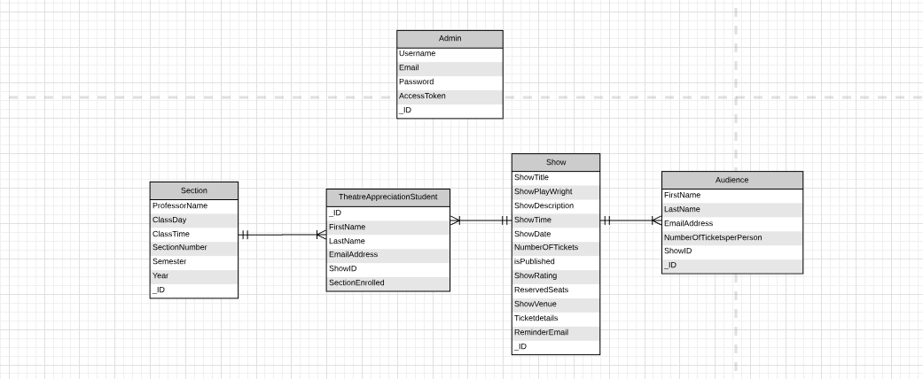

Figure 4.1

1. **System Requirements:**

* Windows 10 and above
* Node.JS version 10.0.0 and above
* Git version 2.19.0 and above

1. **Tools:**

* **Visual Studio Code**
  + Download and install visual studio code from the link <https://code.visualstudio.com/>
  + We will use this application for editing the code.

Below are the steps for Visual Studio Code Installation:

* After navigating to the following link: <https://code.visualstudio.com/>. Click on “Download for Windows (Stable Build)”.

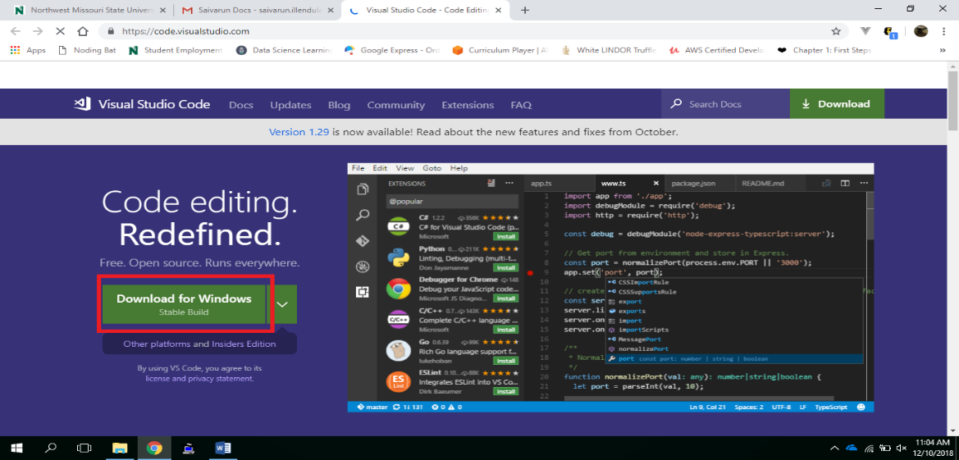

Figure 6.1

* After clicking on the Download for Windows (Stable Build) a .exe file will begin downloading.

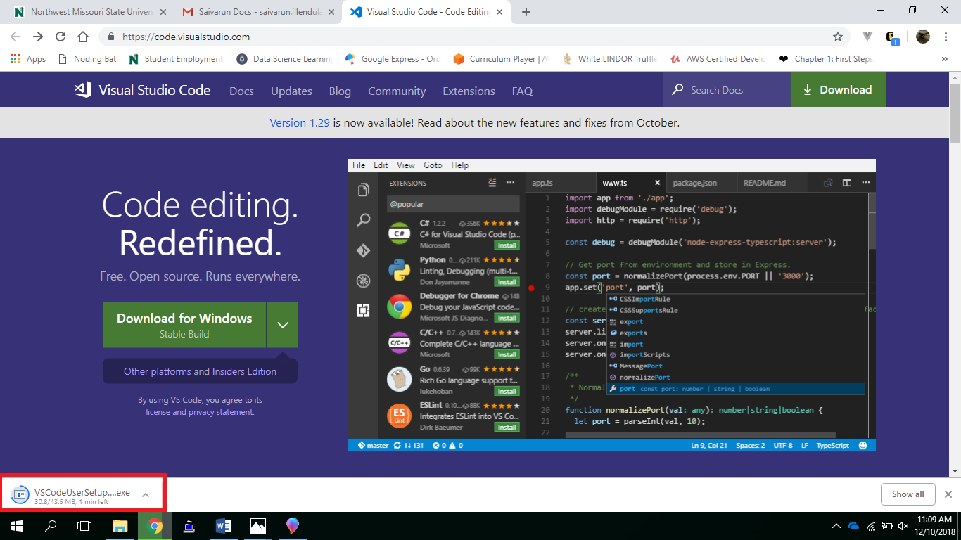

Figure 6.2

* After the file completes downloading, open the .exe file for installation. The Setup wizard appears.

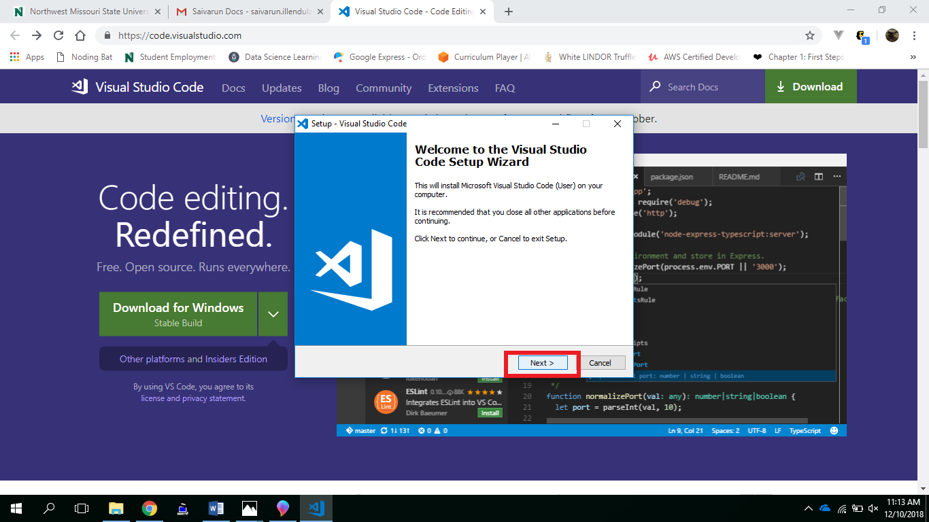

Figure 6.3

* In the setup wizard click on next to continue and then accept the license agreement.

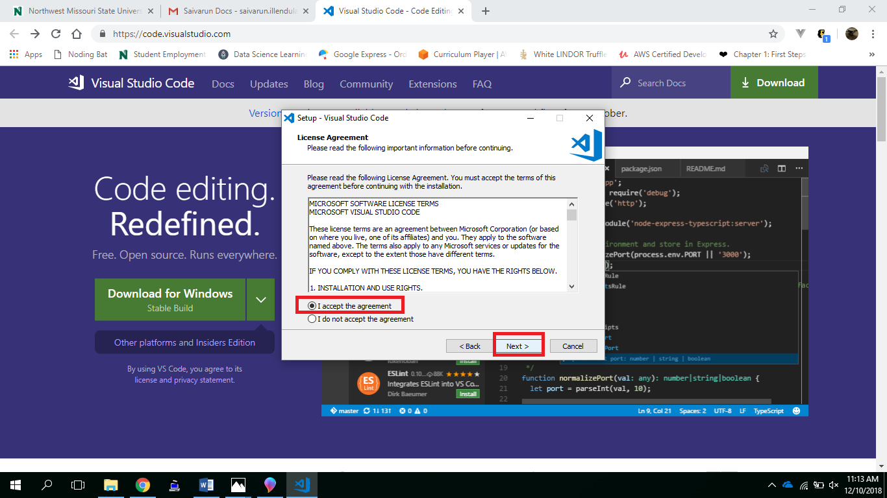

Figure 6.4

* After accepting the license agreement, Click on Next to continue.
* After checking the valid path, click on Next.

(Note: Visual Studio Code will require 185.5 MB of disk space to be able to install on your machine).

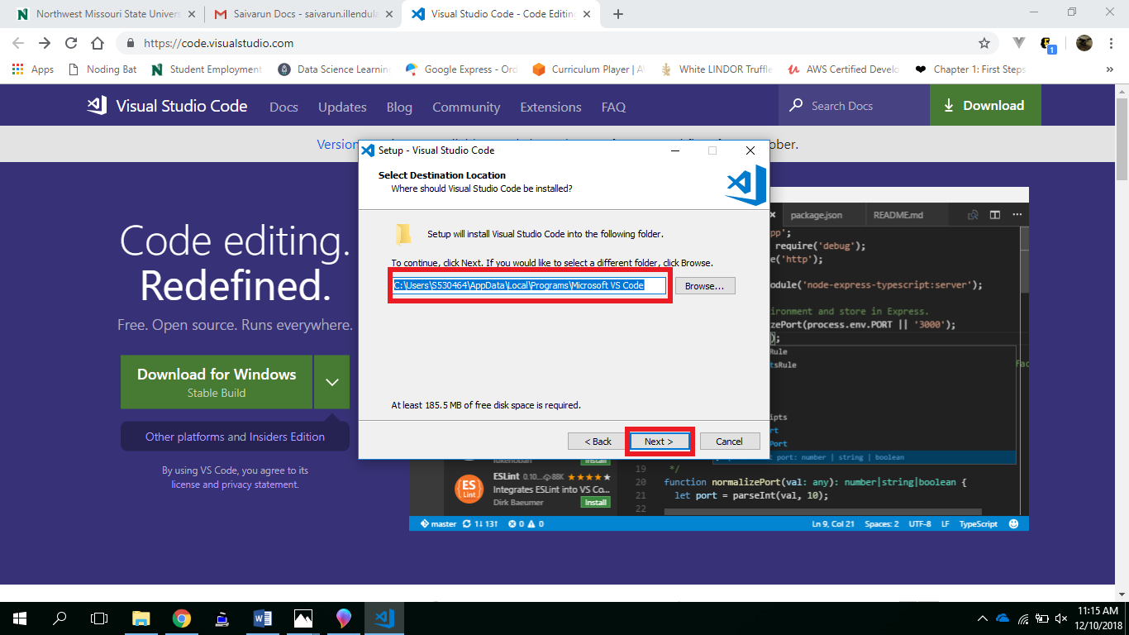

Figure 6.5

* In the Select Start Menu Folder, select if you want to create a Start Menu Folder for Visual Studio Code and then to proceed click on Next.

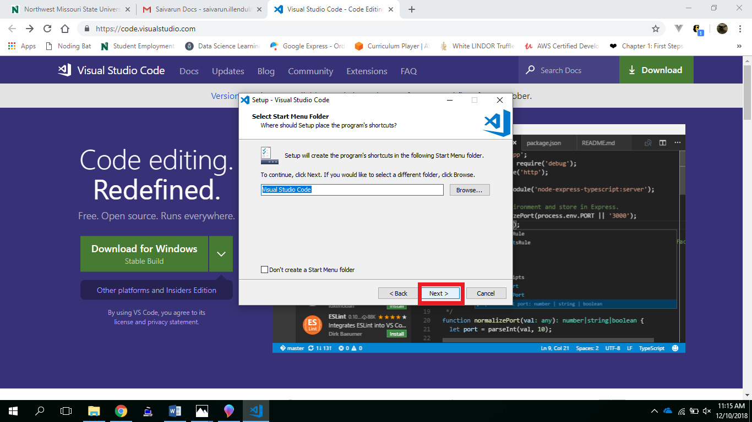

Figure 6.6

* In the Select Additional Tasks Dialog Box, make sure to check all the boxes and click on Next to continue.

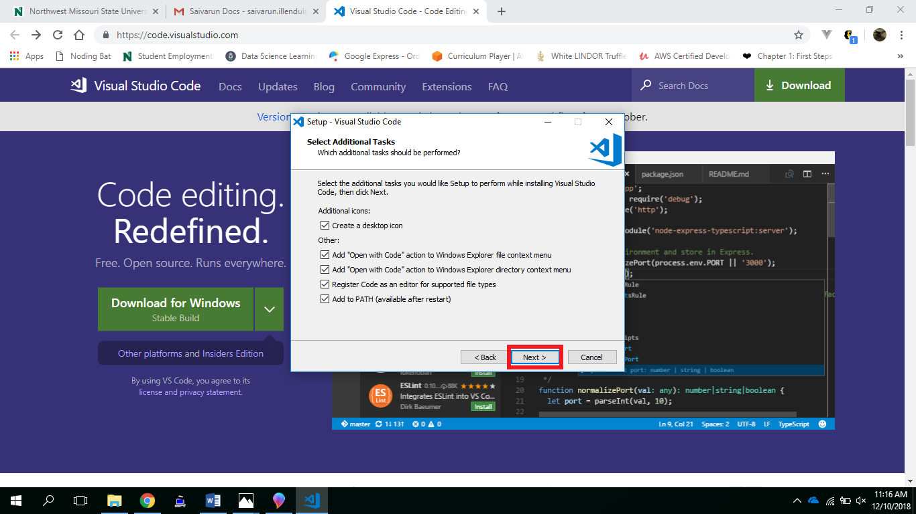

Figure 6.7

* After clicking on Next, in the Ready to Install Dialog Box, click on Install.

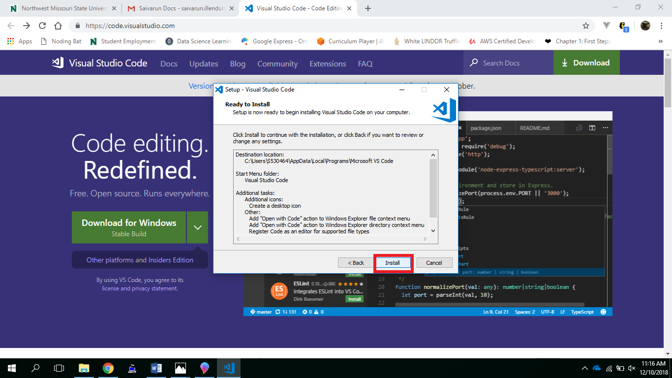

Figure 6.8

* After clicking on Install, the Visual Studio Code will begin installing.

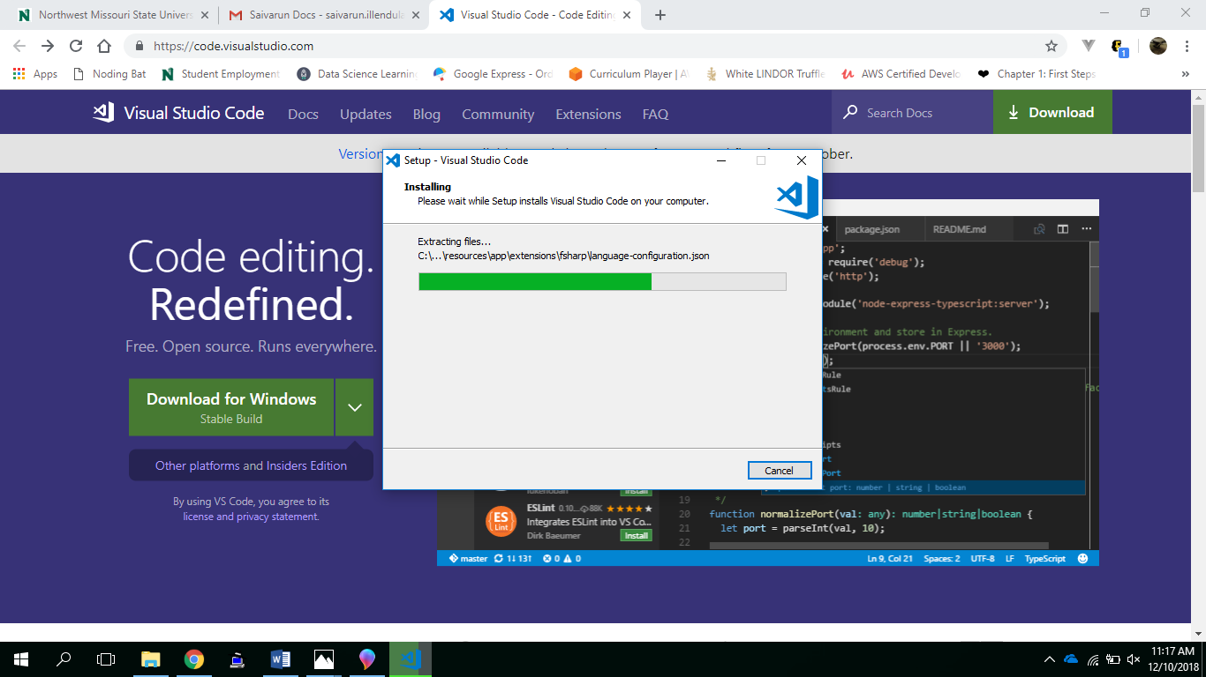

Figure 6.9

* After the installation completes, click on Finish.

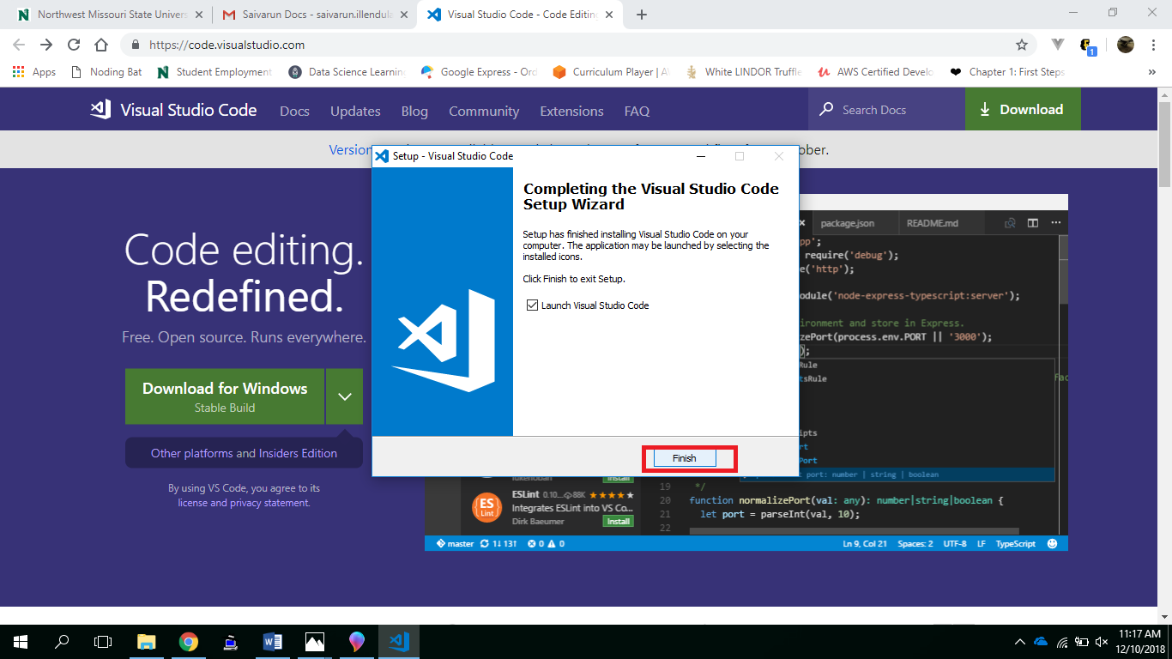

Figure 6.10

* **Postman**
  + Download and install postman from the link <https://www.getpostman.com/apps>.
  + We will use this application for testing API’s.

Below are the steps for Postman Installation:

1. After navigating to the link: <https://www.getpostman.com/apps>. Choose the platform Postman for Windows and Click on Download.

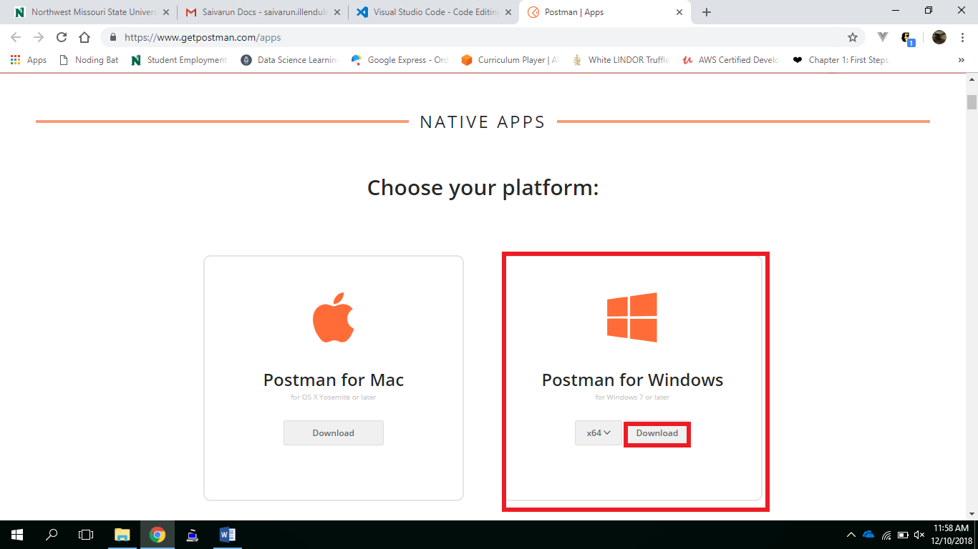

Figure 6.11

1. After clicking on download, Postman will begin downloading the .exe file on your machine as shown below.

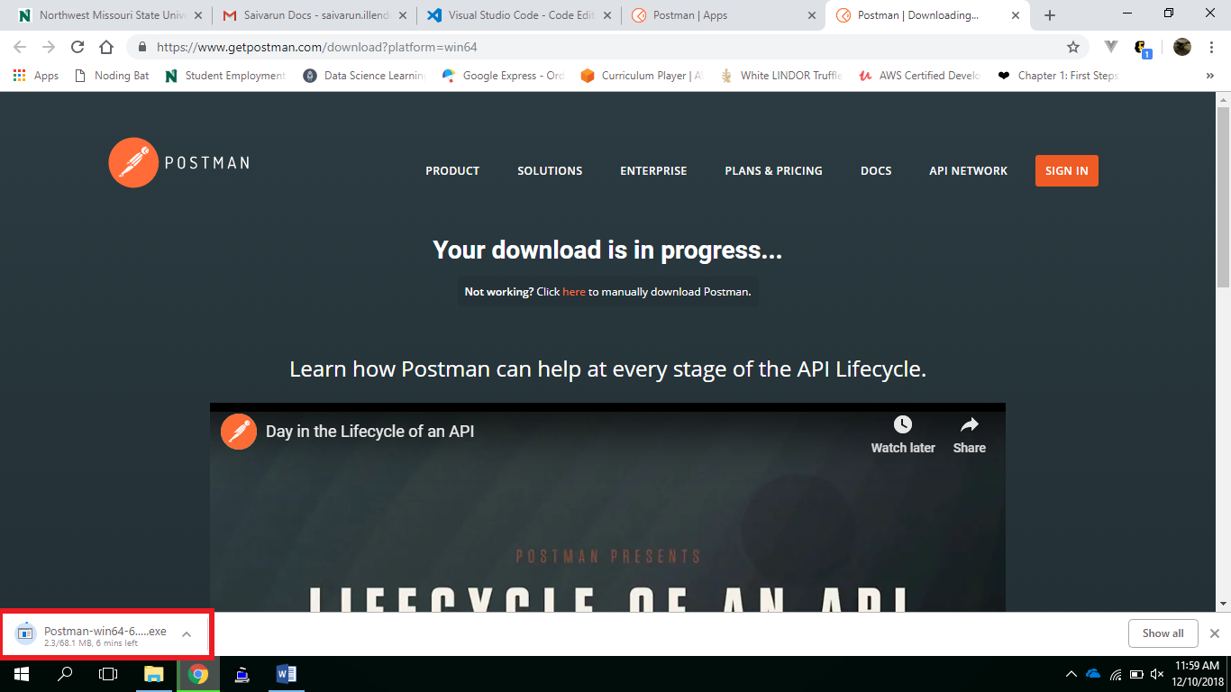

Figure 6.12

1. After the .exe file downloads open the file, Postman will begin setting up its environment and finally ready to use as shown below:

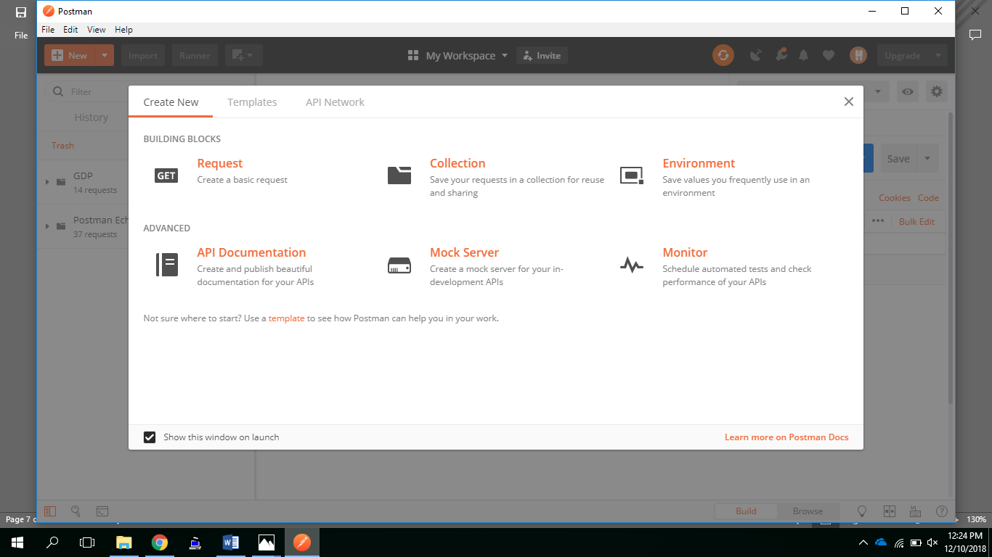

Figure 6.13

* **Tortoise Git**
  + Download and install tortoise git from the link

<https://tortoisegit.org/>.

* + This application has GUI for using Git in our system.

Steps showing installation:

* + - 1. By clicking on the link above, you will be directed to the following page. Click on download.

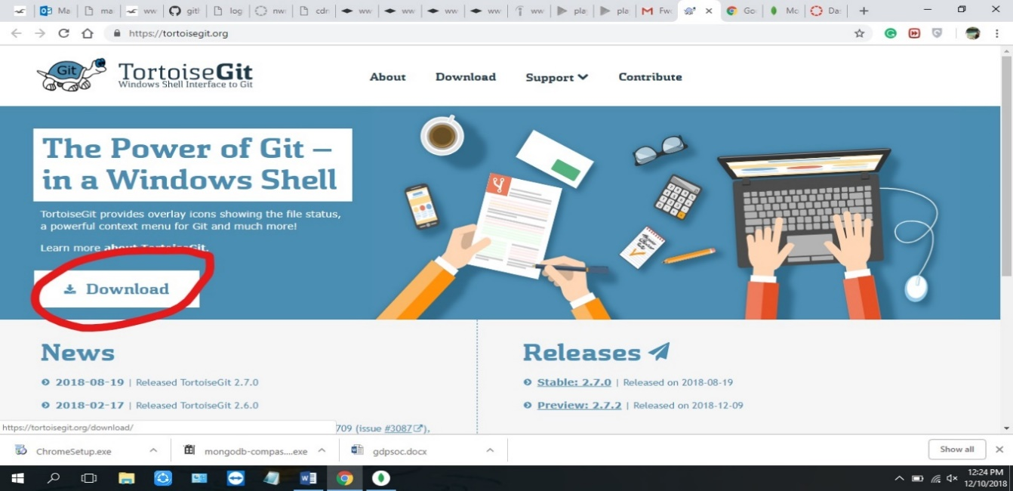

Figure 6.14

2. Select the download version for 64 bit windows.

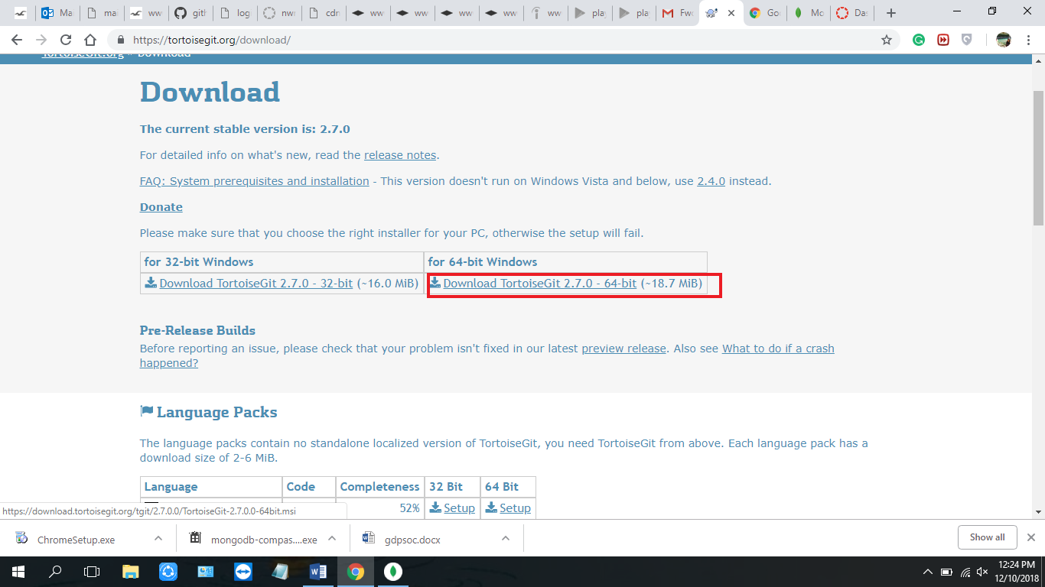

Figure 6.15

3. When the download is completed, a pop-up showing the setup of the tool will be appeared on the screen.

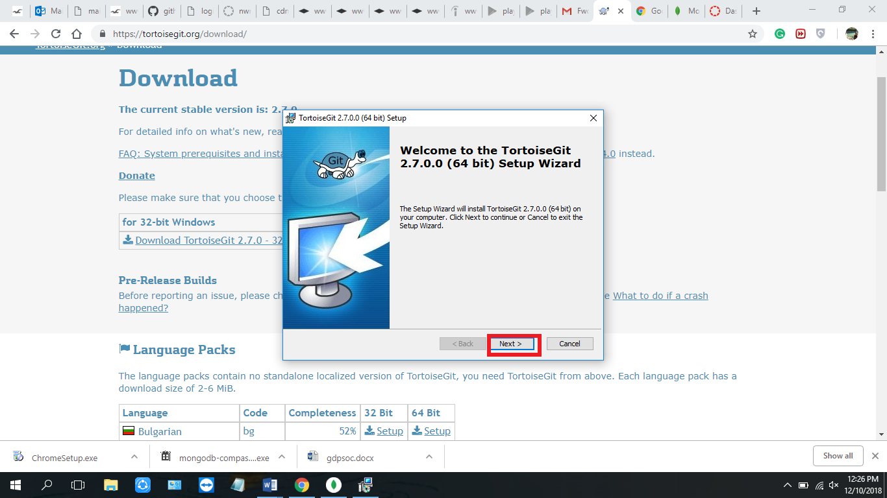

Figure 6.16

4. The following screens show the steps to install tortoisegit.

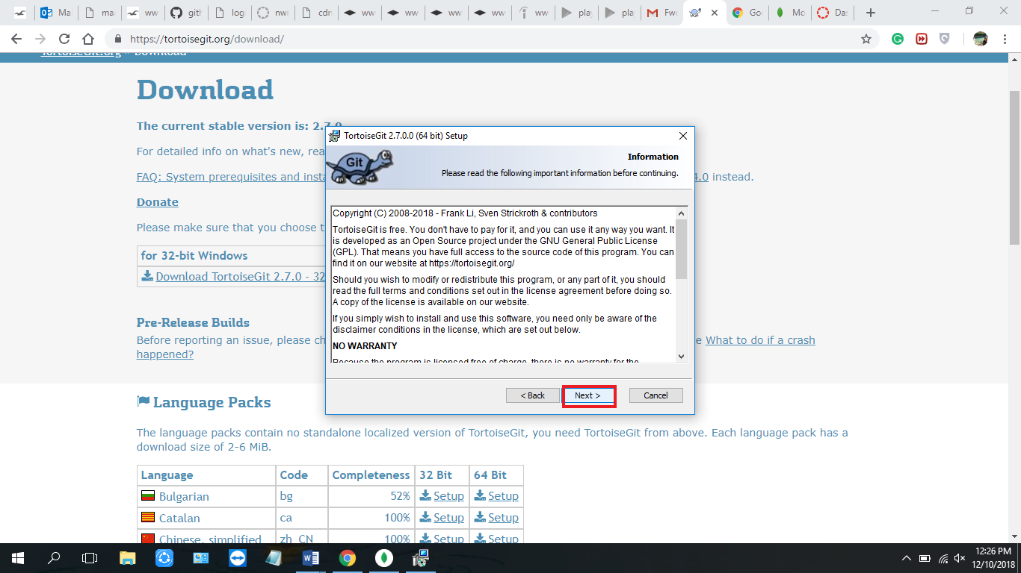

Figure 6.17

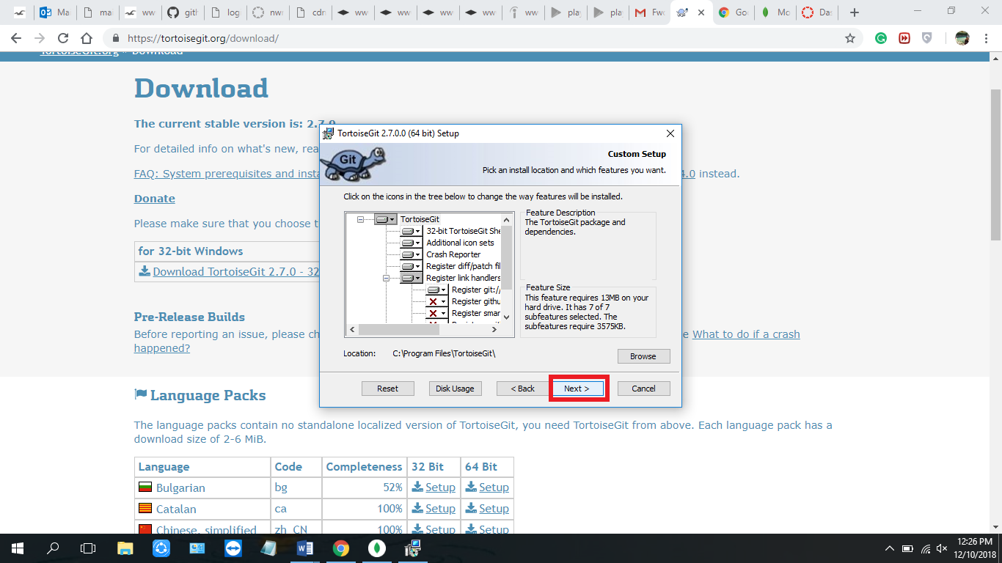

Figure 6.18

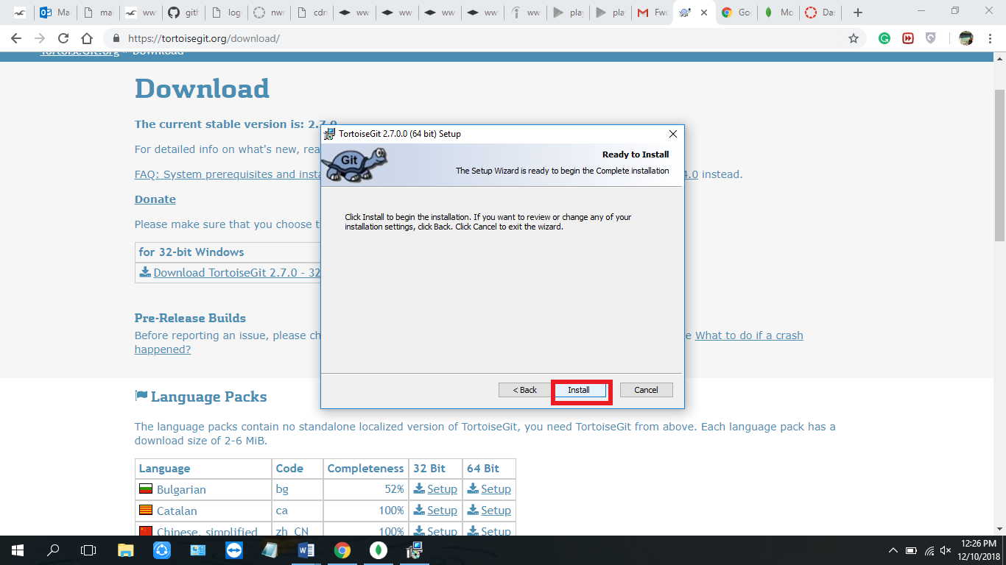

Figure 6.19

5. After clicking on install, the installation will be completed and we can click on ‘Finish’

which shows that the tool is ready to be used.

* **Google Chrome Browser**
  + Download and install Google Chrome from the link <https://www.google.com/chrome/>.
  + We will use this application to test User Interface.
    - 1. By going to the link above, we will be redirected to the following view.

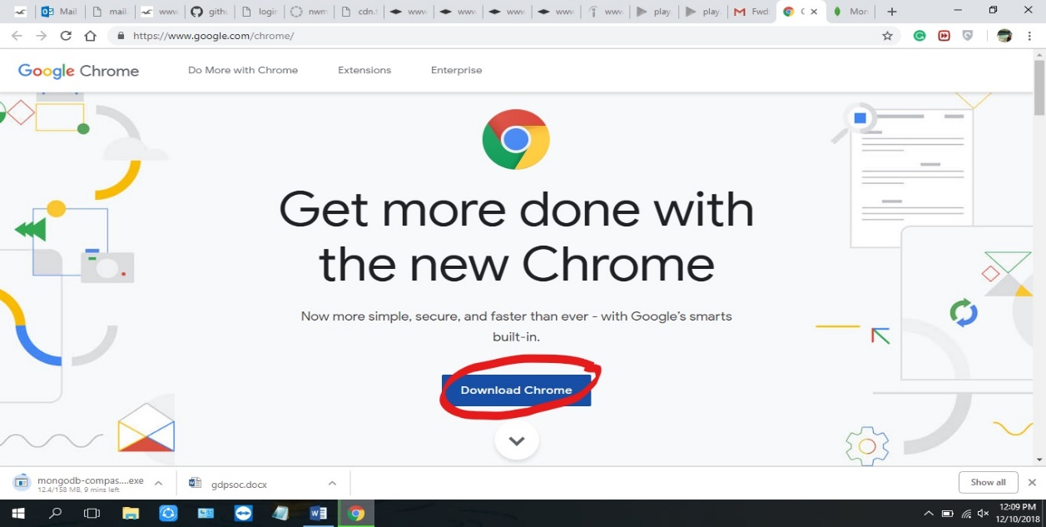

Figure 6.20

* + - 1. 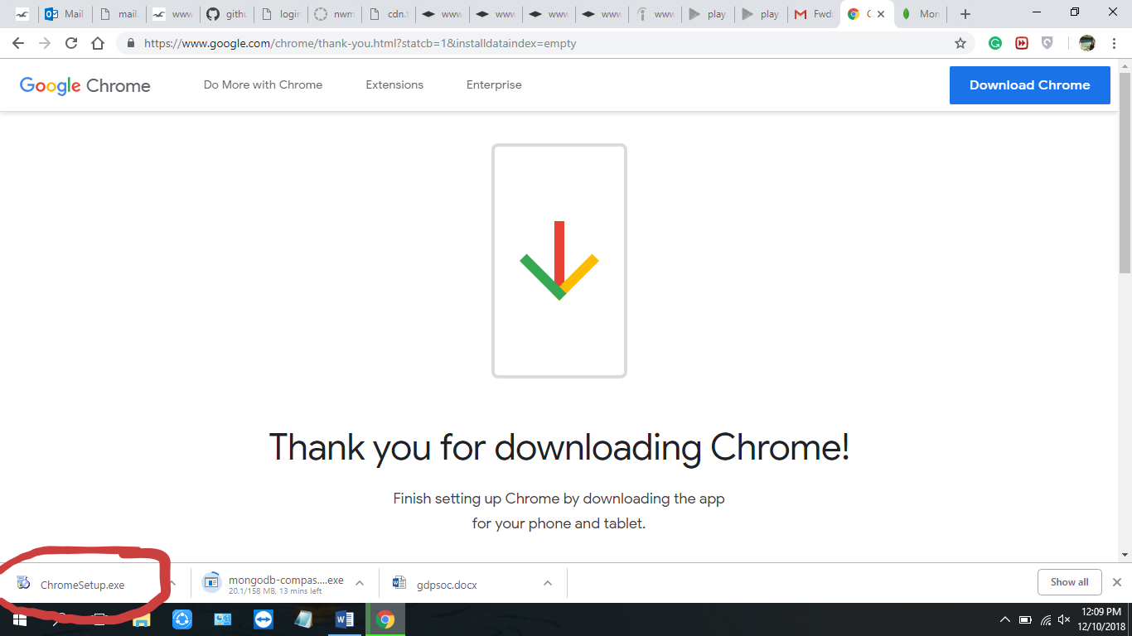 After clicking on the download button, agree the terms and conditions an install chrome.

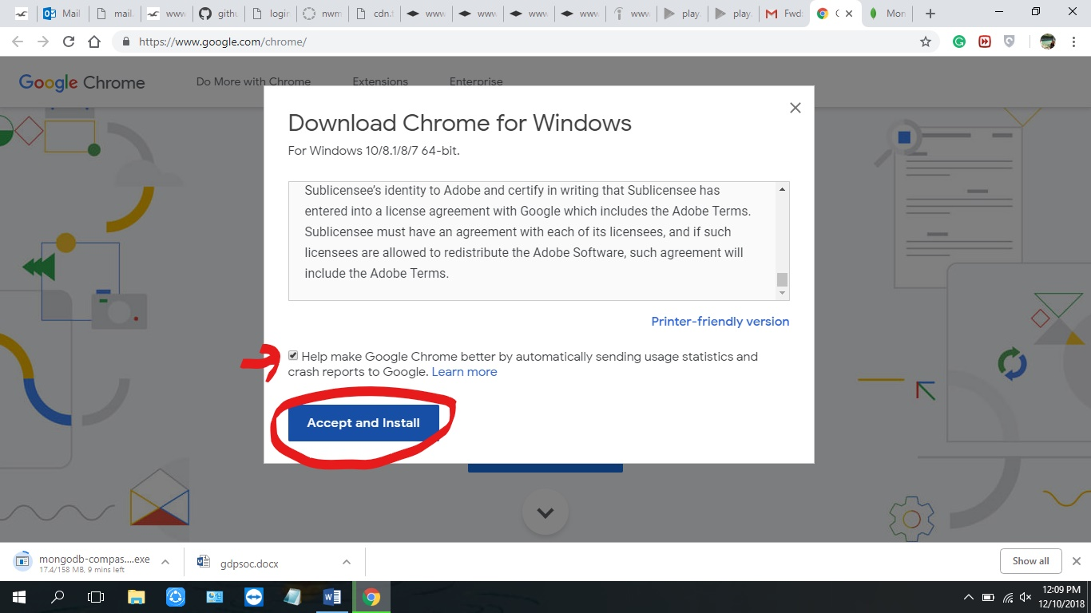

Figure 6.21

* + - 1. After the download of the exe file is done, it can be click opened.
      2. The application starts downloading.

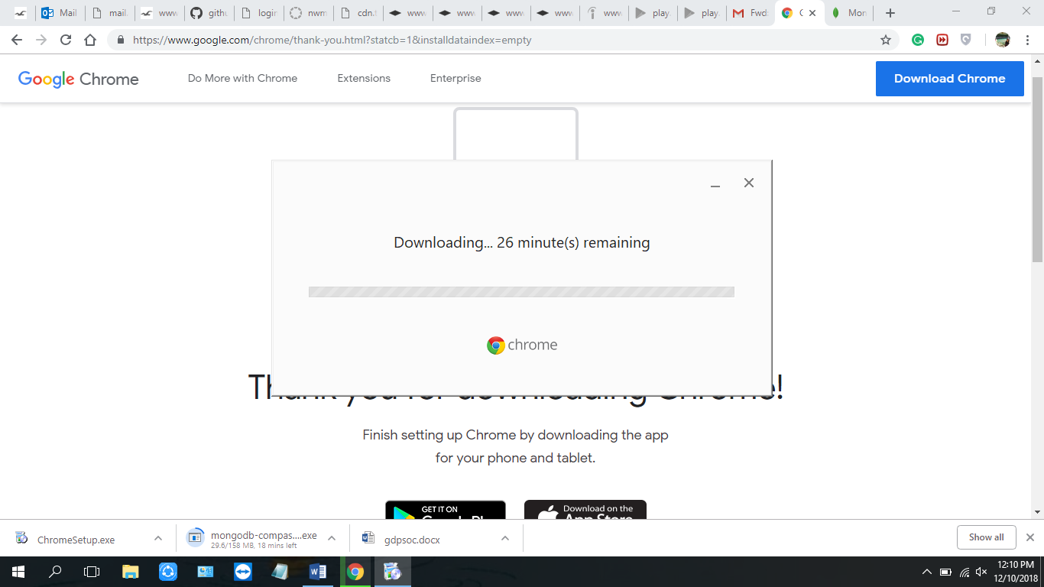

Figure 6.22

5. A message is displayed once the application is automatically installed.

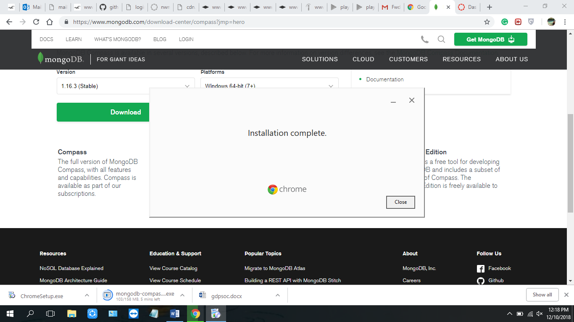

Figure 6.23

* **MongoDB Compass**
  1. Download and install MongoDB Compass from the link <https://www.mongodb.com/products/compass>.
  2. This application has User Interface for MongoDB. We can see the data which resides in Database.
     + 1. Home page of the Mongo Compass. Click on try it now.

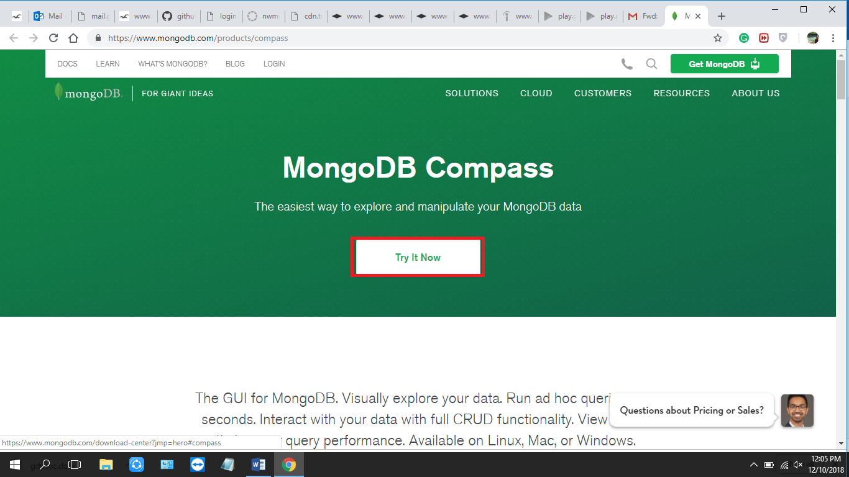

Figure 6.24

* + - 1. Select the version of the compass to be stable.

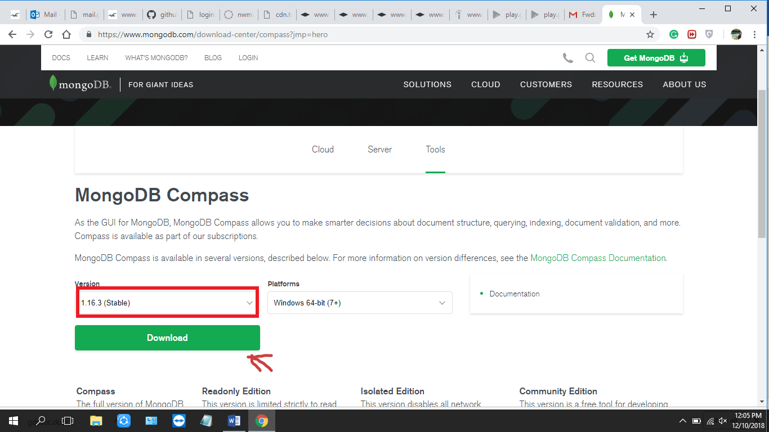

Figure 6.25

3. When clicked on the download button it asks for the details of the user. Fill in the details and submit the form.

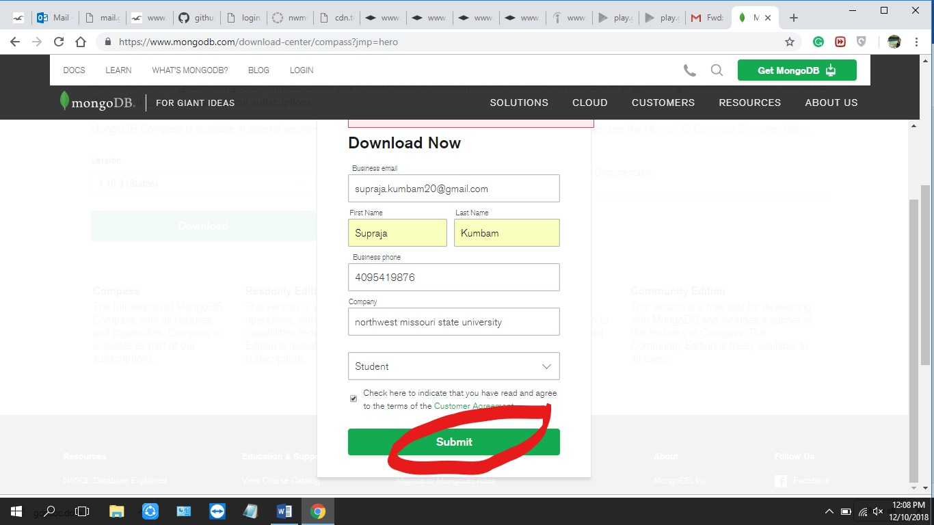

Figure 6.26

4. The exe file is downloaded.

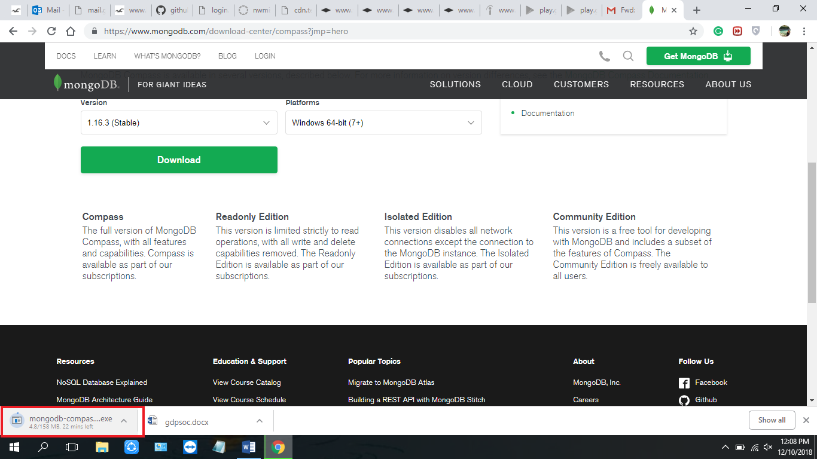

Figure 6.27

5. After clicking on the downloaded exe file of mongo compass, the following screen will appear.

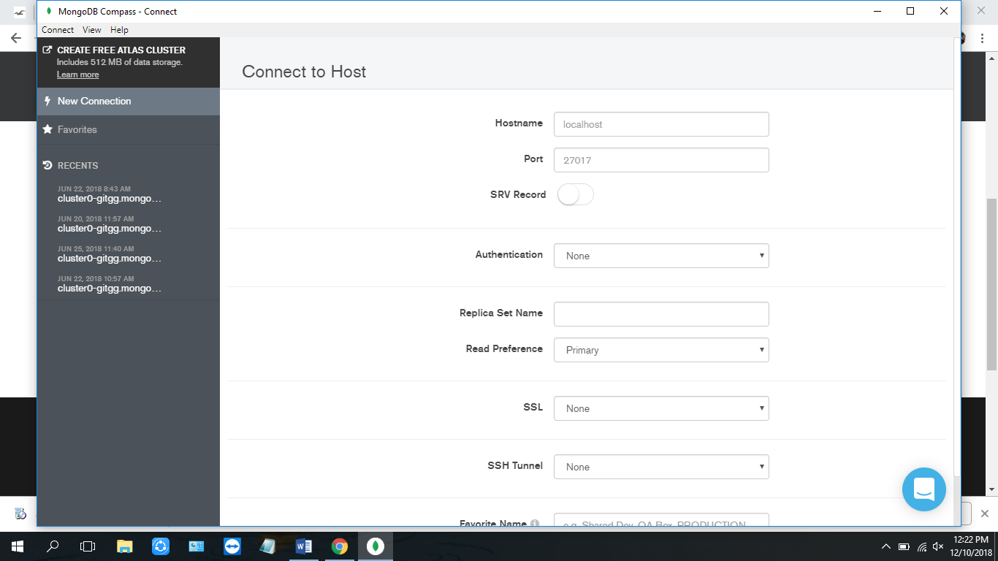

Figure 6.28

**Technologies:**

* **MongoDB Atlas**
  1. Register and create an account at <https://www.mongodb.com/>.
  2. We will use this cloud service to host our application database.
* **Vue.js**
  1. This is a JavaScript framework used to build Single Page Applications.
  2. We will use this framework to build our frontend webpages
* **Node.js**
  1. This is a JavaScript Platform where we can build web services.
  2. We will use this technology to build our backend web services.
* **Heroku**
  1. This is a free cloud hosting platform where we can deploy our application.
  2. We will be deploying our backend services application to Heroku.

1. **Developer Manual:**

**7.1 Instructions to execute the project:**

(**Note:** Please ensure your machine complies to all the system requirements and has all the tools and technologies mentioned above.)

1. Clone the project onto your machine from the GitHub Repository using the following link:

<https://github.com/SanthoshBonala/GDP.git>

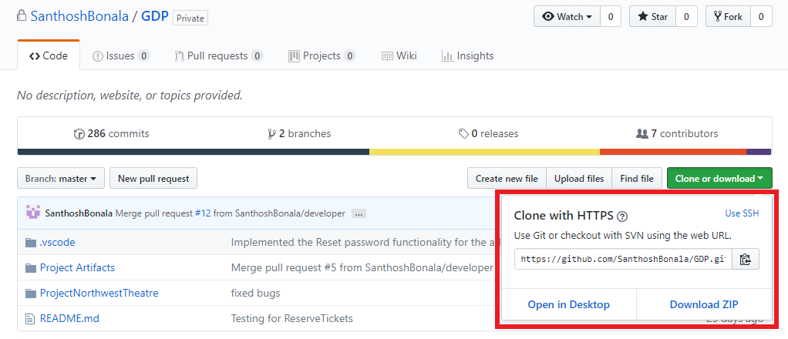

Figure 1

1. After cloning the project on your machine, you will notice the project folder as follows:

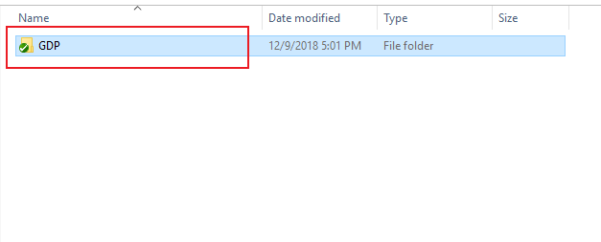

Figure 2

1. Open the project folder, and open the folder named “ProjectNorthwestTheatre”.

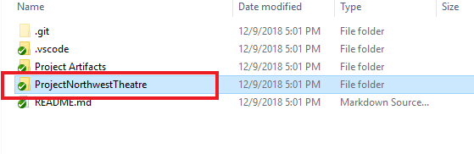

Figure 2

1. In the “ProjectNorthwestTheatre” folder open the folder contents with code as follows:

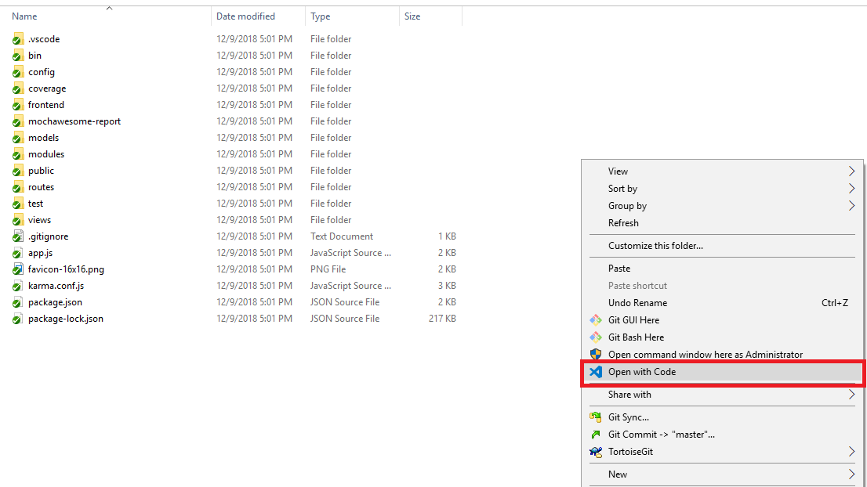

Figure 2

1. The Visual Studio Code opens the “ProjectNorthwestTheatre” as follows:

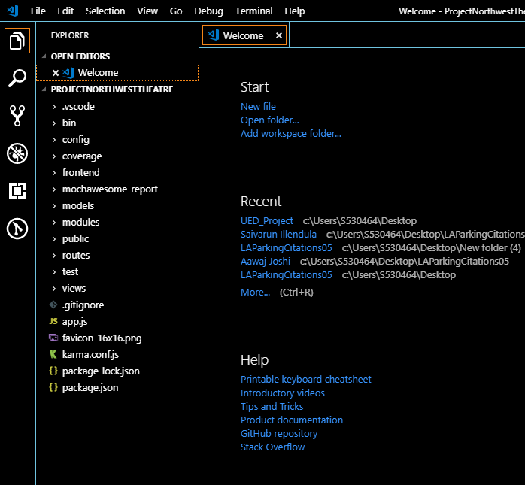

Figure 2

1. To run the project in the Visual Studio Code, click on the “View” option in the navigation bar and click on “Terminal”.

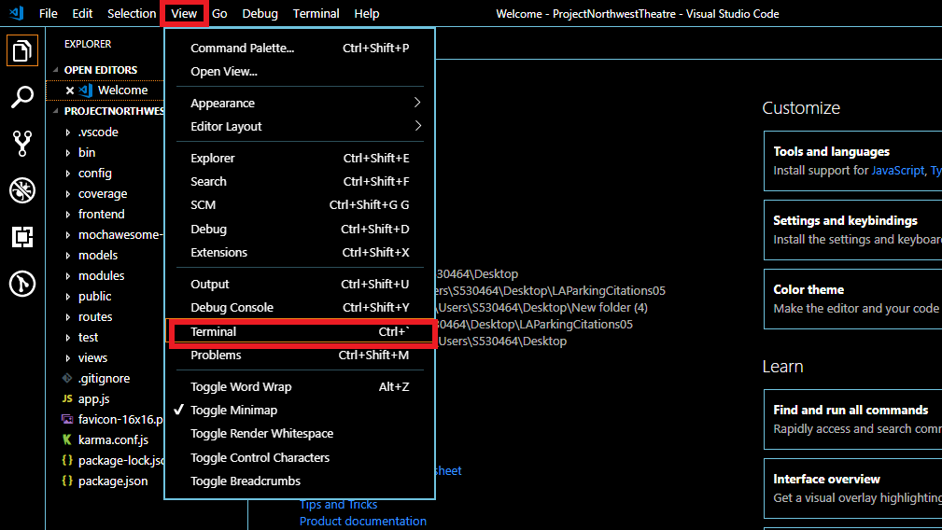

Figure 2

1. After clicking on the “Terminal” you will notice a terminal screen at the bottom of the screen in the Visual Studio Code.

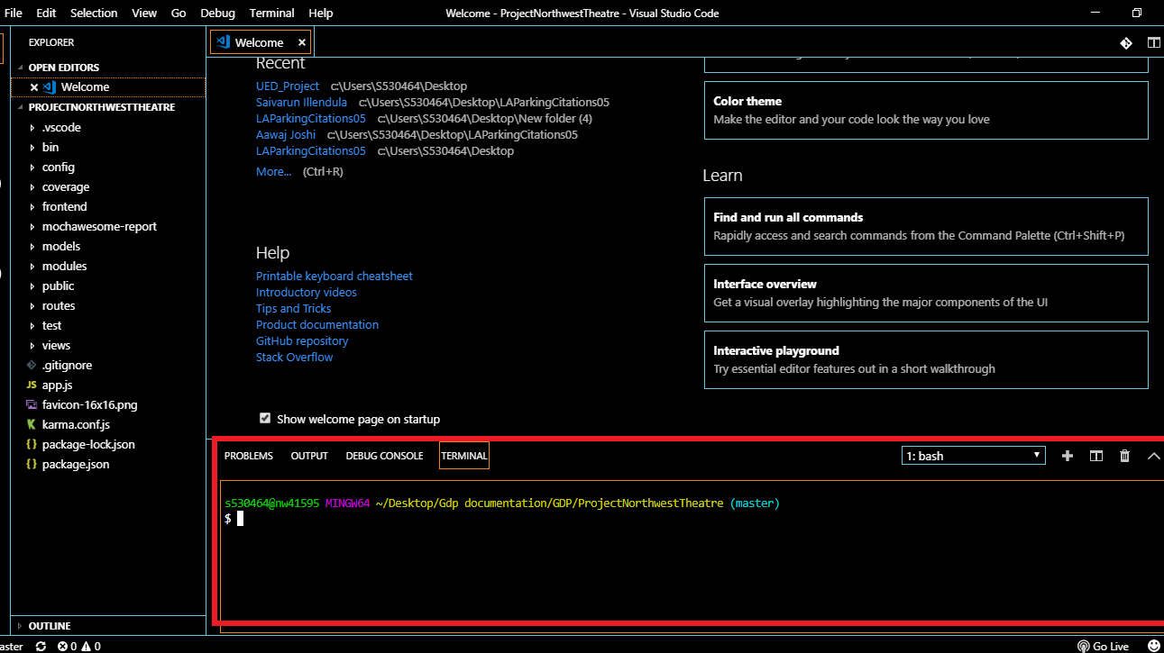

Figure 2

1. In the Terminal window type in **npm install** to install all the necessary dependencies to run the project as follows:

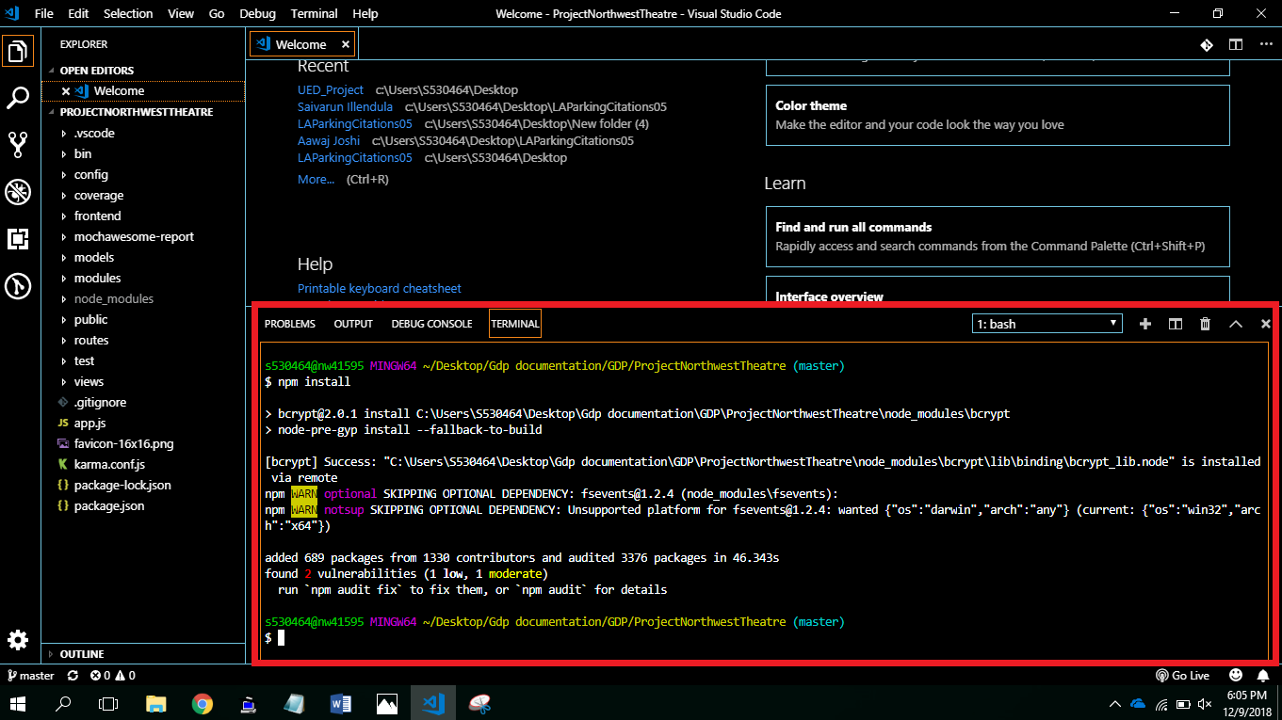

Figure 2

1. After installing all the necessary dependencies for the project, to connect the project to the backend, type in **npm start** as follows:

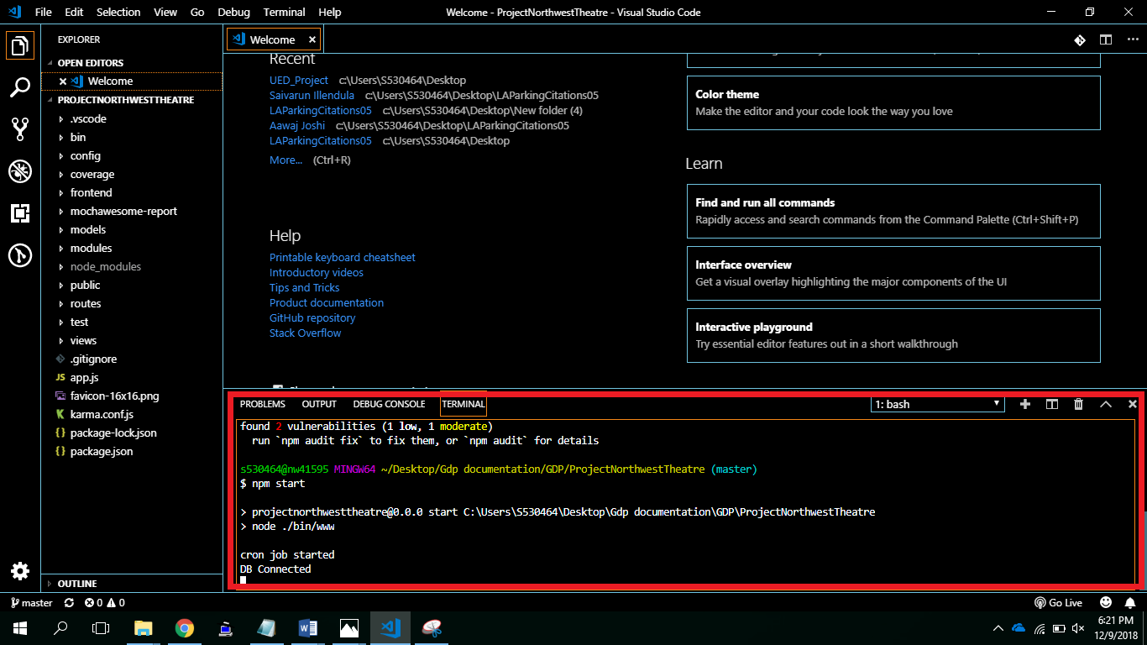

Figure 2

1. After establishing the database connection, in the Terminal window open a new window by clicking on the “+” button.

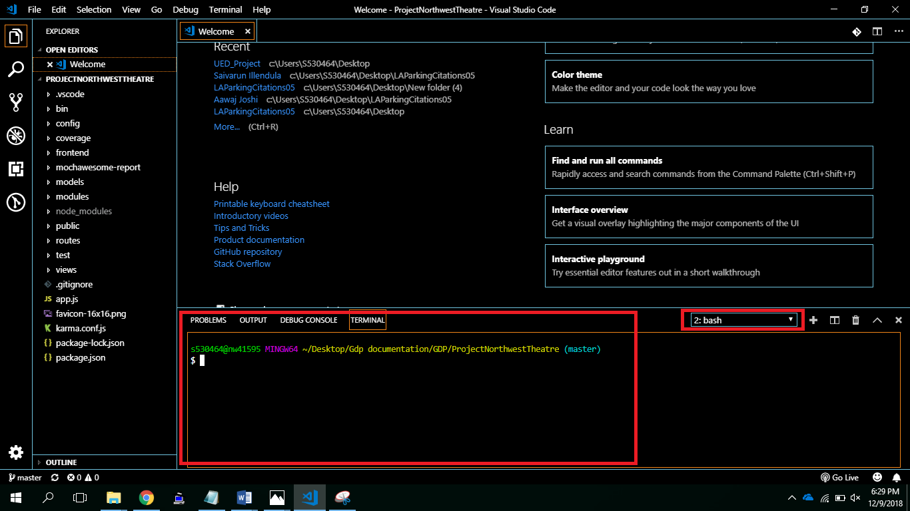

Figure 2

1. Use the command **cd frontend** to navigate to the “frontend” folder in the project as follows:

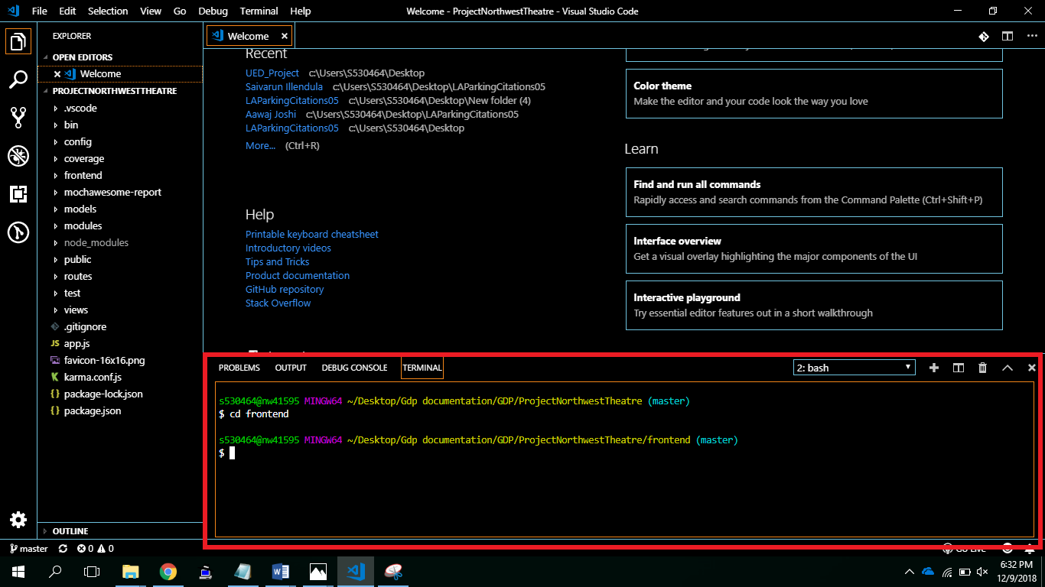

Figure 2

1. After navigating to the frontend folder, type in **npm install** all the dependencies in the frontend as follows:

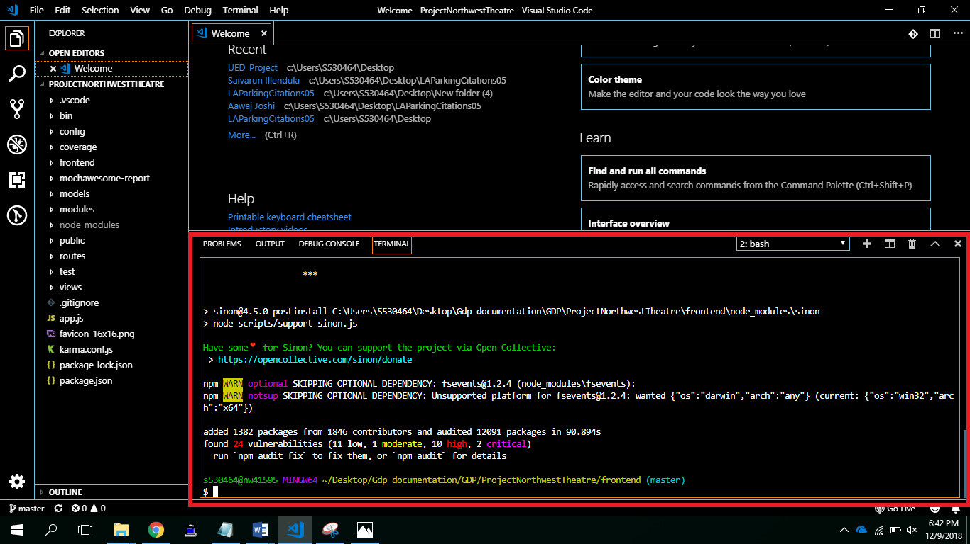

Figure 2

1. After installing all the dependencies, to run the project execute the following command **npm start**.

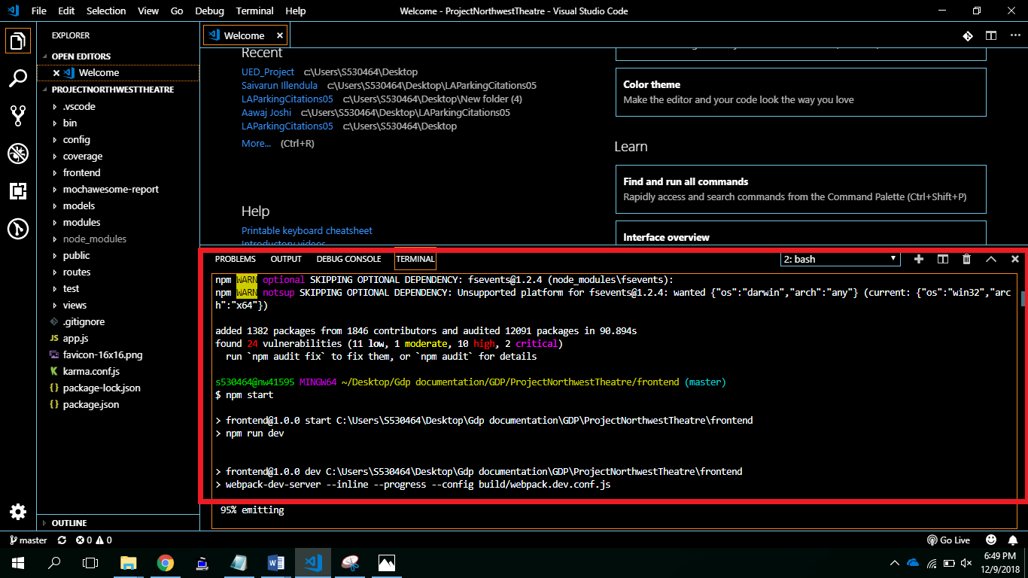

Figure 2

1. **Problems Faced**

**8.1 List of all the Errors encountered:**

1. The older version of NodeJS prevented the application to be hosted on deployment platforms like AWS. The error encountered while executing the project with older version of NodeJS was as follows:

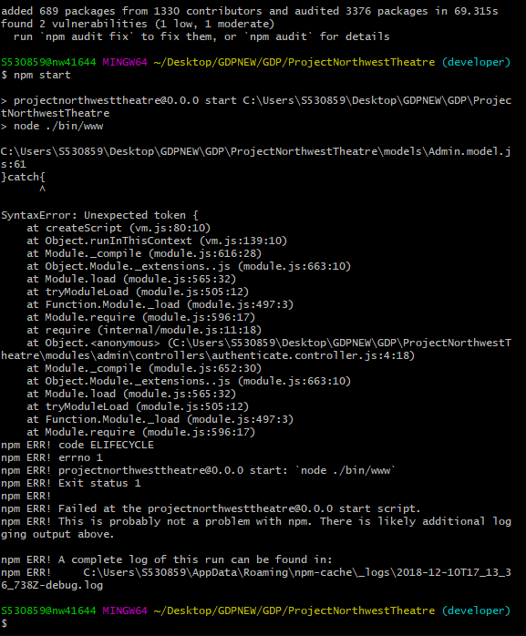

Figure 8.1

*To resolve this error, the user is required to update the version of NodeJS to version 10 or later.

(**Note:** Please refer to the system specifications for the latest version of NodeJS in use)

1. After installing NodeJS on your machine make sure you include the environment variable (if not already present) with the path “**C:\Program Files\nodejs**”.

The error encountered with the absence of this environment variable is as follows:

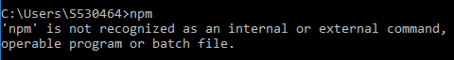

Figure 8.2

*To resolve this error, we need to add the environment variable manually. The steps involved to add the environment variable if it is not added automatically by the machine are:

1. Click on Windows.
2. Open the Control Panel.
3. In the Control Panel items, Select System as shown in the below figure:

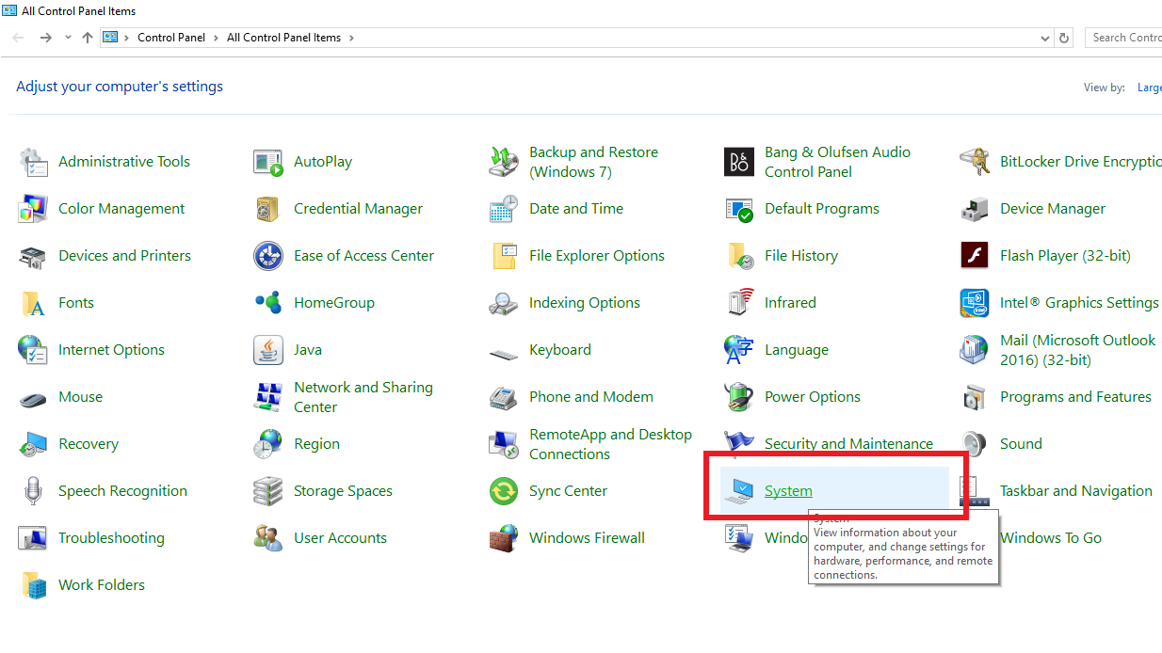

Figure 8.3

1. After selecting System from the Control Panel options, click on the “Advanced System Settings”.

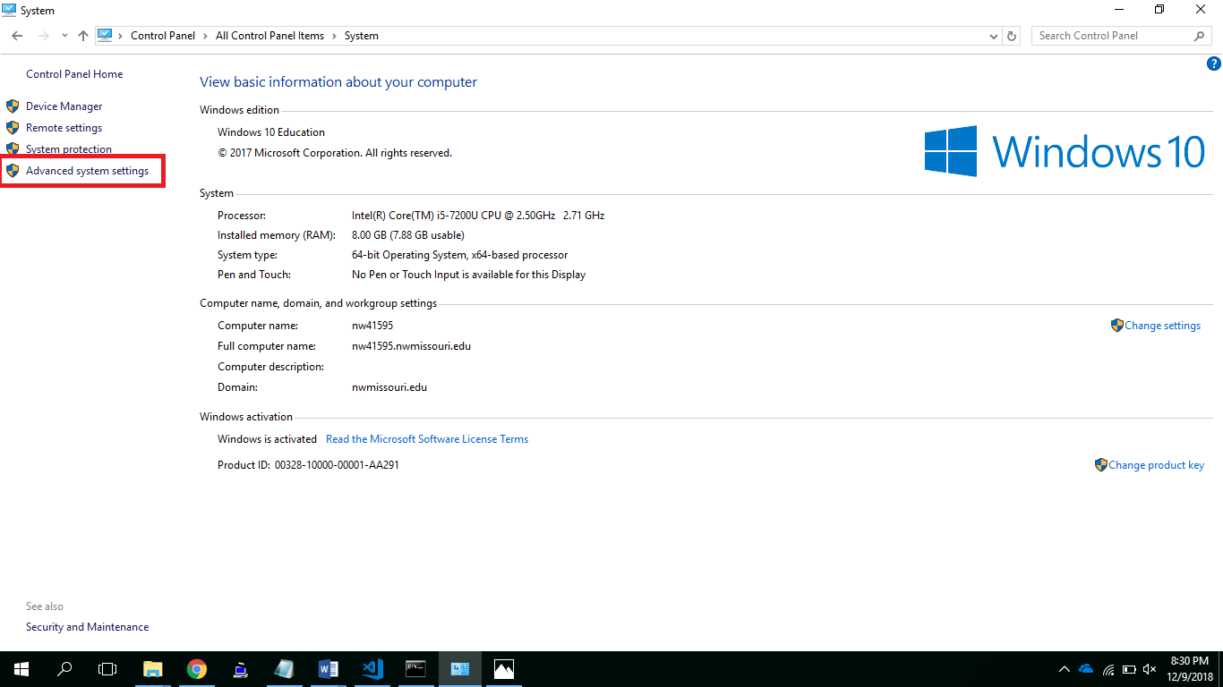

Figure 8.4

1. In the Advanced System Settings, click on the Environment Variables as shown below,

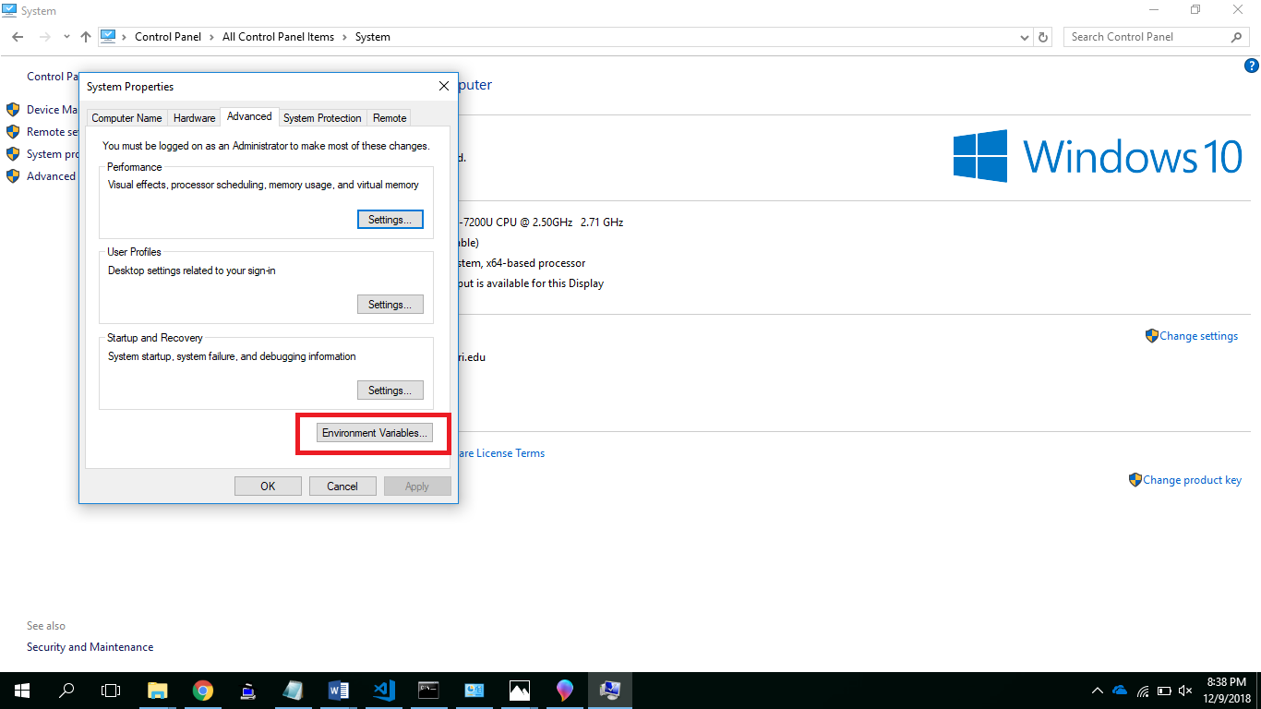

Figure 8.5

1. After clicking on the Environment variables, click on “**Edit**” under **System Variables** to add a new environment variable to the list of existing environment variables.

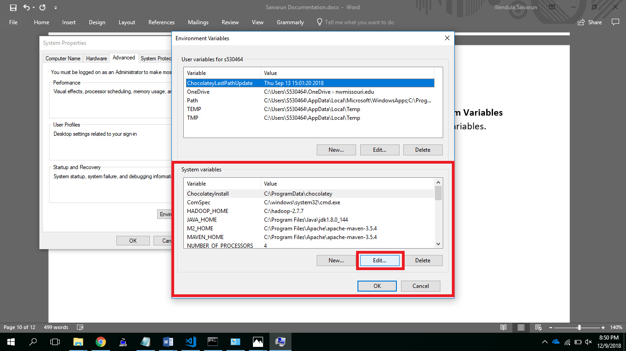

Figure 8.6

1. Add the new path “**C:\Program Files\nodejs”** to the list of existing environment variables. This will resolve the error.
2. **Testing**

**9.1 Unit Testing:**

UnitTesting is a level of software testing where individual units/ components of a software are tested. For back-end testing we are using mocha, chai and mocha-awesome and for front-end testing we are using karma, mocha, vue-test-utils.

**9.2 Running Test Cases:**

**Back-end:**

* Change directory to backend using the following command
  + Cd ProjectNorthwestTheatre/
* Open terminal at current directory
* Run the tests using the following command
  + npm test

**Front-end:**

* Change directory to backend using the following command
  + Cd ProjectNorthwestTheatre/frontend/
* Open terminal at current directory
* Run the tests using the following command
  + npm test

**Test Results:**

* After running the test, we can see the reports generated in the following directory for backend
  + ProjectNorthwestTheatre/mochawesome-report
* Below is the screenshot for the test we have executed

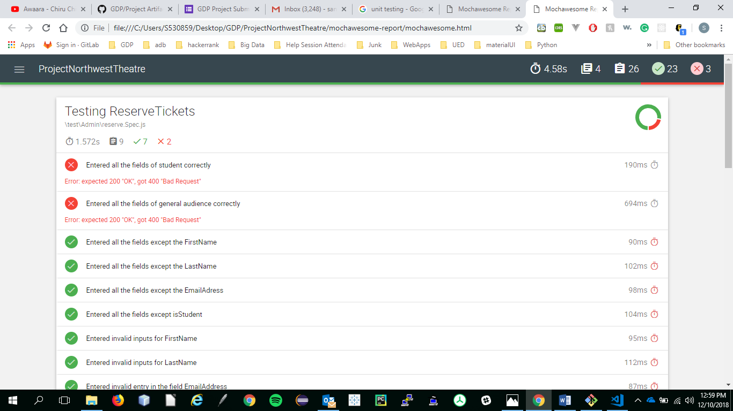

Figure 9

1. **List of Incomplete Functionalities:**

* Unit Testing Backend API’s
* Unit Testing Frontend

1. **User Manual:**

**Passwords**

For this application login is required for only admin. Below are the listed passwords required for login

|  |  |
| --- | --- |
| **Username** | **Password** |
| admin | @Dmin123 |
|  |  |

Further the admin can create a new password by following the instructions in admin part.

**URL:**

**Admin URL’s:**

|  |  |
| --- | --- |
| **Admin Page** | **URL path** |
| **Admin Page** | **URL path** |
| Login | <http://theatrenorthwest.s3-website.us-east-2.amazonaws.com/admin/login> |
| Home | http://theatrenorthwest.s3-website.us-east-2.amazonaws.com/admin/dashboard |
| Add new show | http://theatrenorthwest.s3-website.us-east-2.amazonaws.com/admin/dashboard |
| Admin list | http://theatrenorthwest.s3-website.us-east-2.amazonaws.com/admin/adminlist |
| Add new admin | http://theatrenorthwest.s3-website.us-east-2.amazonaws.com/admin/addadmin |
| View section | http://theatrenorthwest.s3-website.us-east-2.amazonaws.com/admin/sectionlist |
| Add section | http://theatrenorthwest.s3-website.us-east-2.amazonaws.com/admin/addsection |
| Cancel ticket | http://theatrenorthwest.s3-website.us-east-2.amazonaws.com/admin/cancelticket |
| Audience view | http://theatrenorthwest.s3-website.us-east-2.amazonaws.com/userView/user/dashboard |
| Email remainder | http://theatrenorthwest.s3-website.us-east-2.amazonaws.com/admin/dashboard |
| Reserve ticket | http://theatrenorthwest.s3-website.us-east-2.amazonaws.com/admin/dashboard |
| Duplicate show | http://theatrenorthwest.s3-website.us-east-2.amazonaws.com/admin/dashboard |

**Audience URL’s:**

|  |  |
| --- | --- |
| **Audience Page** | **URL path** |
| Home | http://theatrenorthwest.s3-website.us-east-2.amazonaws.com/user/dashboard |
| Reserve | http://theatrenorthwest.s3-website.us-east-2.amazonaws.com/user/reserve |
| Cancel ticket | http://theatrenorthwest.s3-website.us-east-2.amazonaws.com/user/cancelticket |
| Directions | http://theatrenorthwest.s3-website.us-east-2.amazonaws.com/user/directions |

**Audience View**

1. This is the audience home page where it contains all the published shows by admin. Audience will be able to search for a show with the help of search field (figure-11.1)

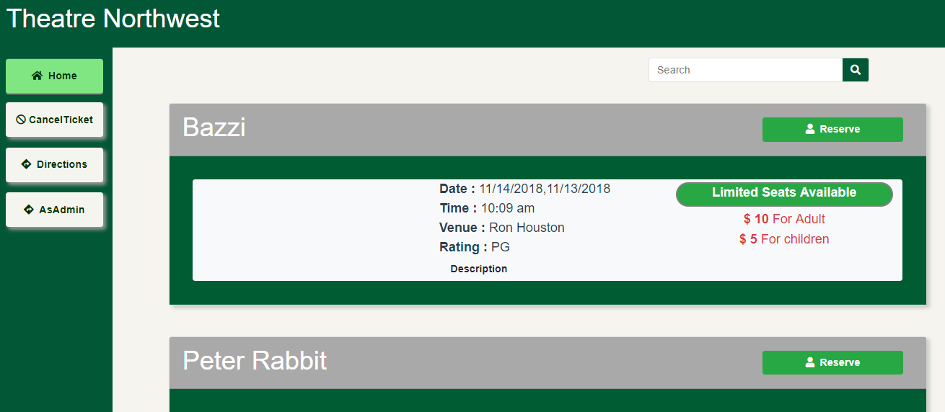

Figure 11.1

1. Description of the audience show card (figure-11.2)

Audience will be able to reserve the ticket by clicking on Reserve button

Inforamtion about seats

Details of the show

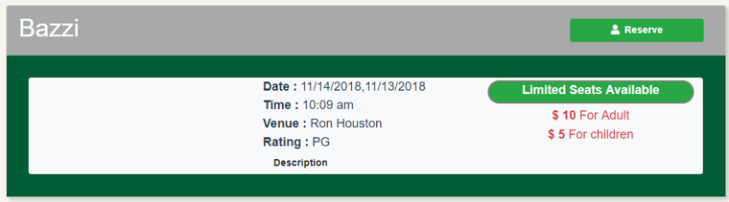

Ticket price for different group

On clicking on Description button a pop up will appear where it contains playwrite and the detailed description of the show.

Figure 11.2

1. On clicking on reserve button audience will be able to reserve seat for the corresponding show. A pop will appear where audience will be able to fill the form with the mentioned attributes on clicking Yes then a select field will appear where theatre appreciation students will be able choose their section in which they have enrolled. (figure 11.3).

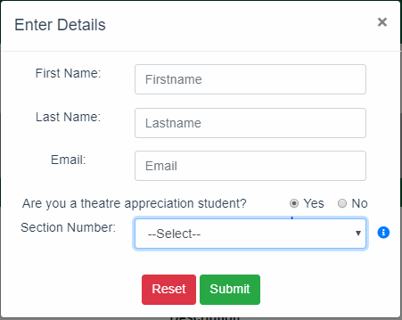

Figure 11.3

1. On clicking on the Cancel Ticket button which is at the side navigation bar then audience will be able to find the email addresses to which request for cancellation of tickets can be sent (figure 11.4)

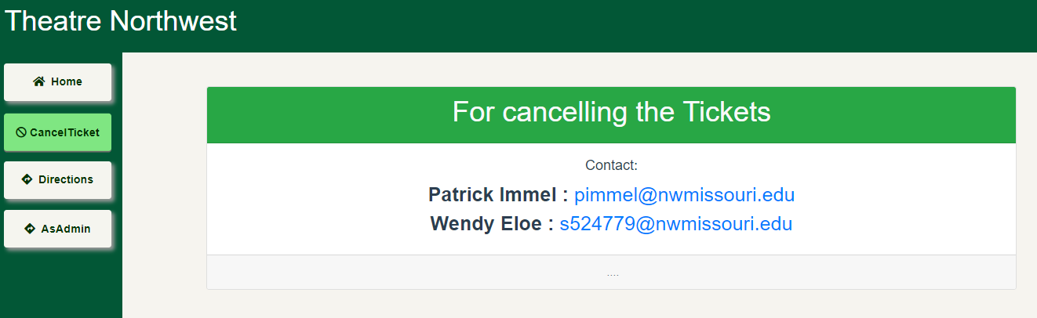

Figure 11.4

1. On clicking on the Directions button audience will be able to see the exact location of the Ron Houston center with the help of the address (figure 11.5)

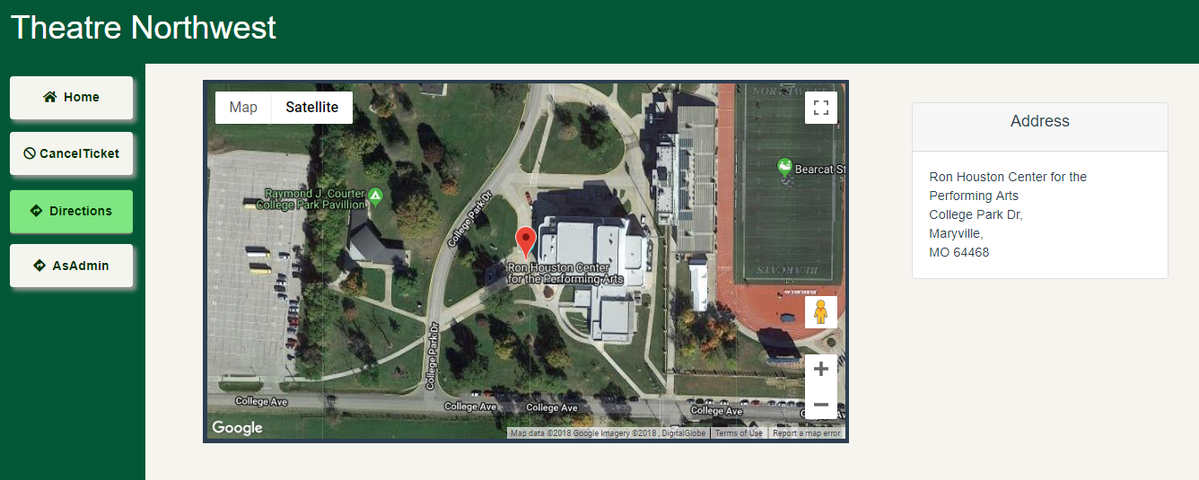

Figure 11.5

**Admin View**

1. This is the admin login page (figure 11.6). where admin must give username and password to login into the application

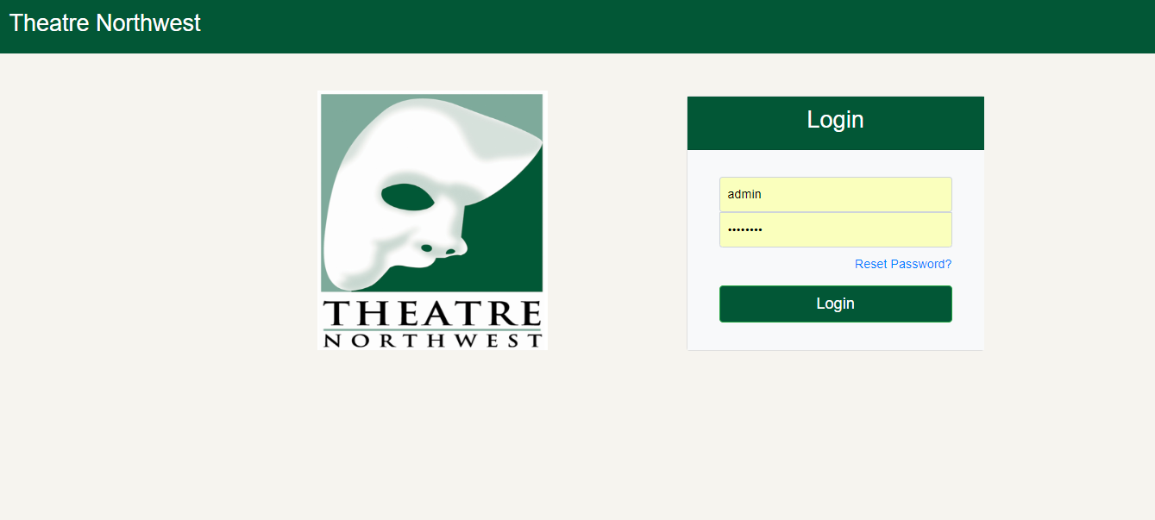

Figure 11.6

1. Once admin login in into the application he/she will be able to see dashboard where it contains all the details of the different shows (figure 11.7)

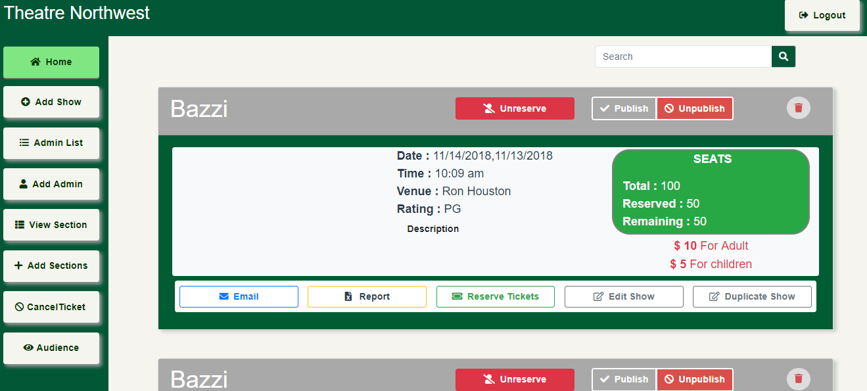

Figure 11.7

Admin will be able to search for a show by entering show name in the search field.

1. Admin will be able to add a new show to the dashboard by clicking on the Add Show button then a popup menu will appear (figure 11.8)

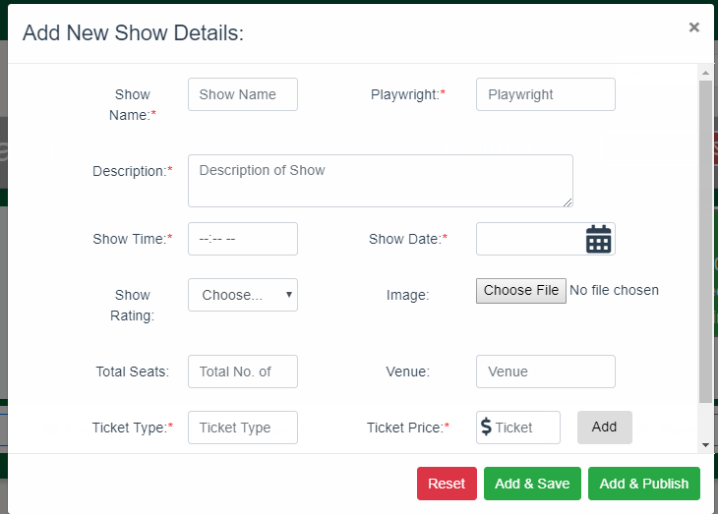

Figure 11.8

Admin will be able to enter all the attributes for the new show and provided with the three options where form can be reset by clicking on the Reset admin, on click on Add & save button this show will be added to admin dashboard but not published to audience and by clicking on Add & Publish button then the show will be added to the admin dashboard and published to audience where audience can see the show on audience dashboard

1. By clicking on the Admin List button admin will be able to see all the admins who can access this application (figure 11.9)

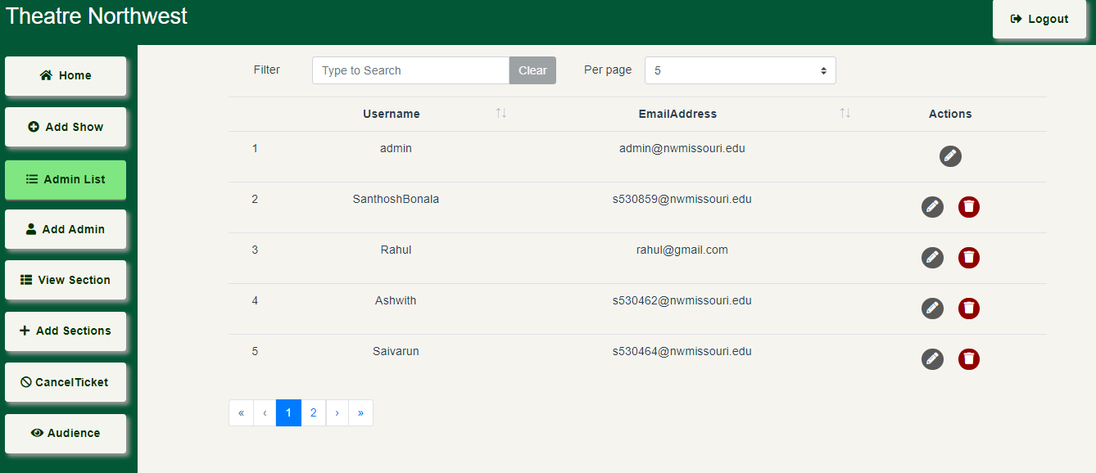

Figure 11.9

1. Admin will be able to add a new admin by clicking on the Add Admin button (figure 11.10)

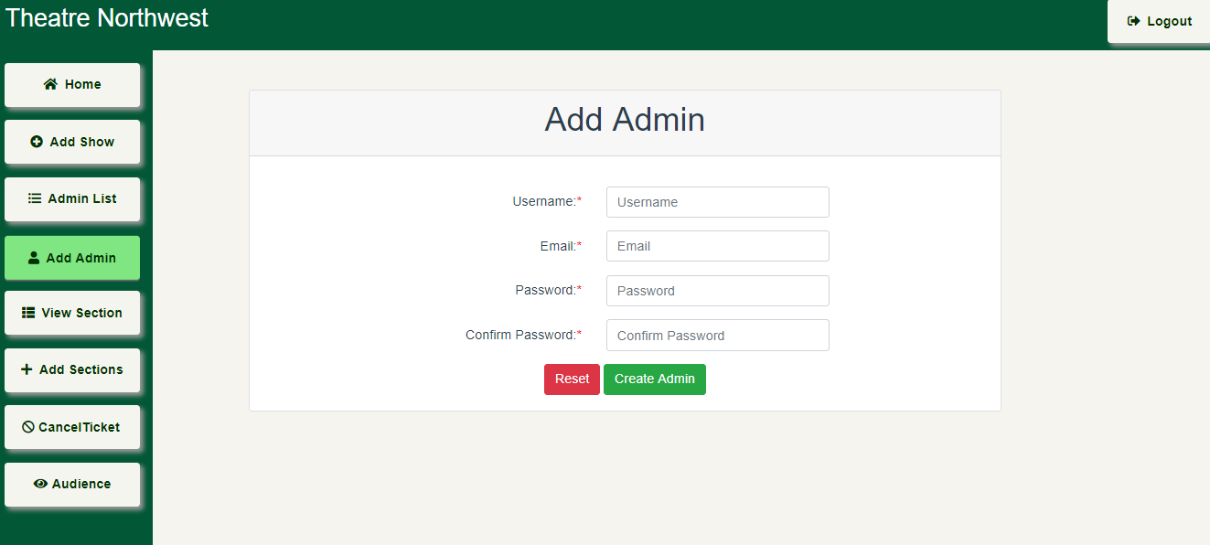

Figure 11.10

1. Admin will be able to see all the sections by clicking on the View Section button (figure 11.11)

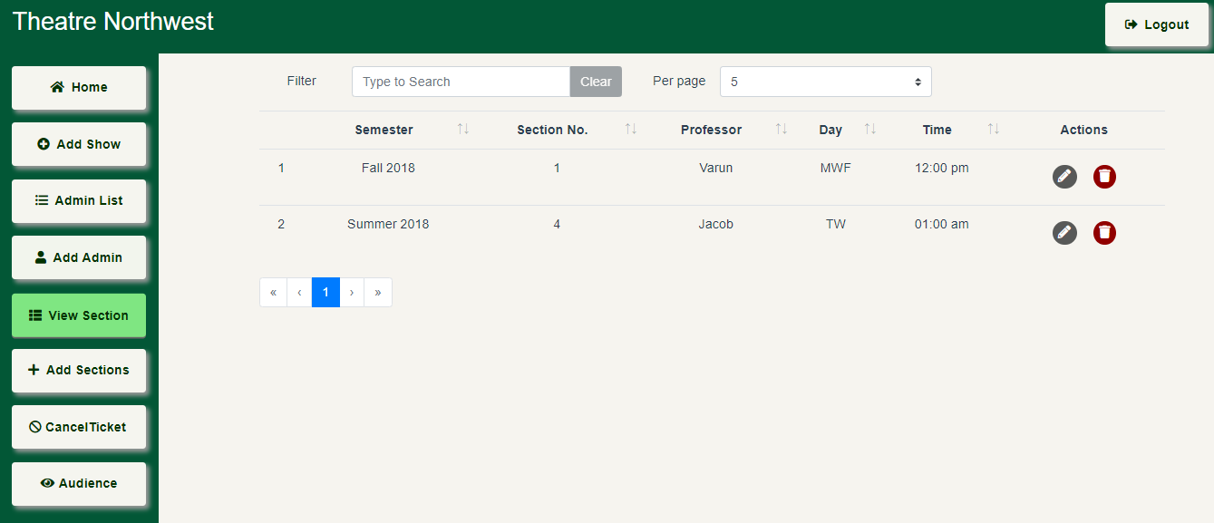

Figure 11.11

1. Admin will be able add a new section by clicking on the Add Section button (figure 11.12)

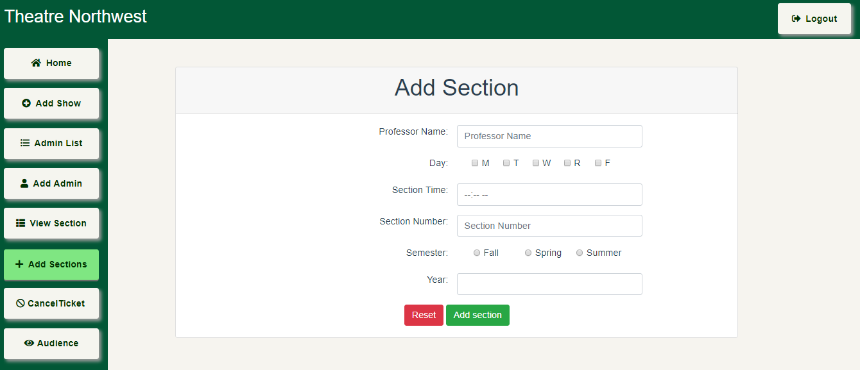

Figure 11.12

1. Admin will be able to post the cancel ticket email-Id for the audience who wants to unreserve the ticket may send the request to the email-id’s posted in Cancel Ticket button (figure 11.13)

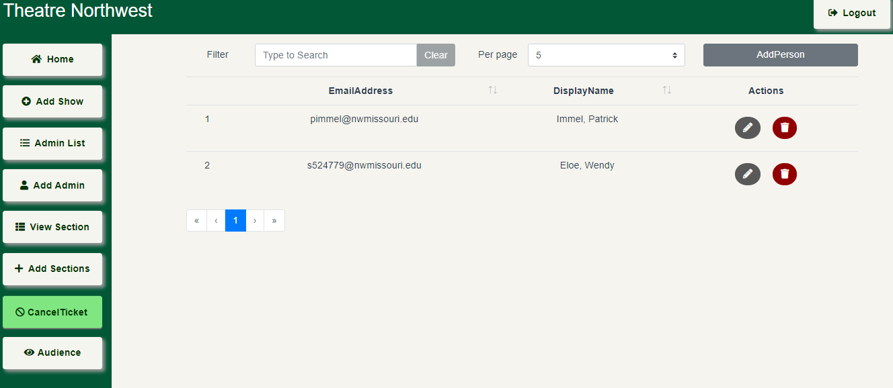

Figure 11.13

Where admin can  (edit) or 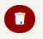 (delete) the existing record by clicking on the respective button. Once the admin clicks on the edit button a popup will appear where details can be updated (figure 11.14). Once the delete button is clicked then confirmation popup will appear (figure 11.15).

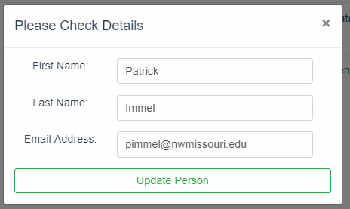

Figure 11.14

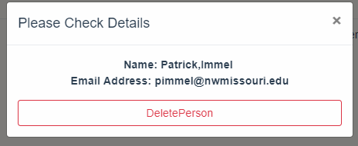

Figure 11.15

1. Admin is provided with Audience button where admin will be able to see the application in the perspective of the audience view (figure 11.16)

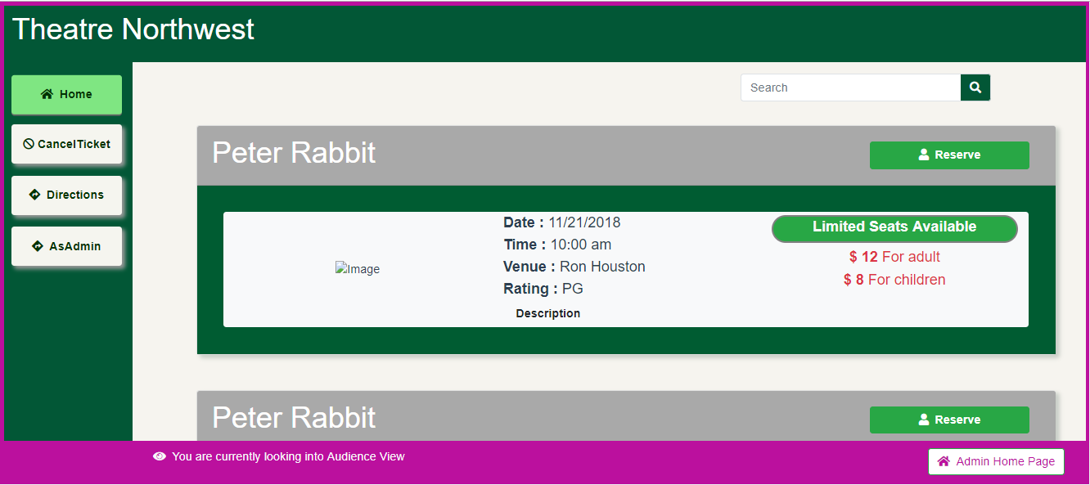

Figure 11.16

1. Audience view is bordered with the pink color to differentiate from the actual admin dashboard and with the help of the Admin Home Page button admin will be able to navigate to admin home page.
2. Audience view is bordered with the pink color to differentiate from the actual admin dashboard and with the help of the Admin Home Page button admin will be able to navigate to admin home page.
3. Admin Show card overview (figure 11.17)

Admin will be able see all the attributes of the show

Admin will be able to unreserve particular audience by clicking on Unreserve button

Admin will be able to delete the show card from dashboard

Admin will be able to see the statistical data of the seats

Admin will be able to Publish or Unpulish

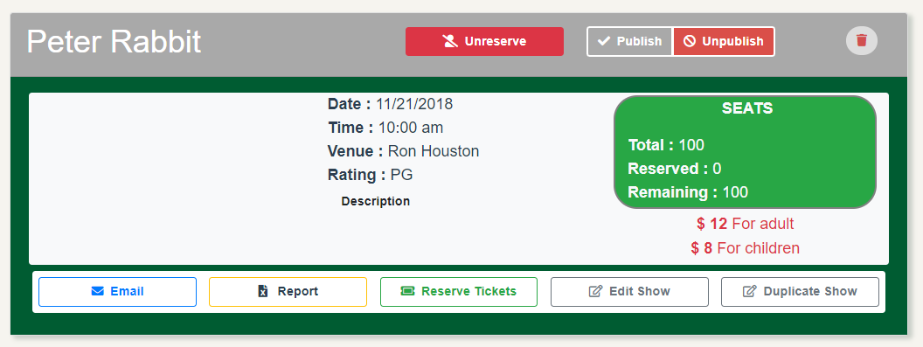

Admin will be able to generate a similar show card this will be helpful when the same show is hosted but on different timings

Admin will be able to send the emails to all the reserved audience in case of any emergency

Admin will be able to reserve tickets for the audience who request for more tickets or in case of any limited seats

Admin will be able to edit the existing show card detail

Admin will be able to generate the report in excel format containing all the details of audience who reserved for show card

Admin will be abel to see the price charges that are applicable for different category

Figure 11.17

1. When admin clicks on Email button a pop will appear (figure 11.18)

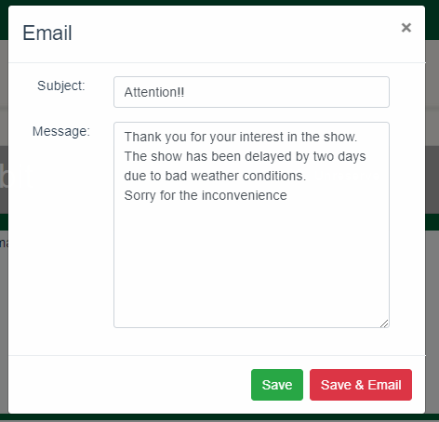

Figure 11.18

1. When admin clicks on reserve ticket a pop will appear. On selecting yes in “Are you theatre appreciation student section number field will appear (figure 11.19)

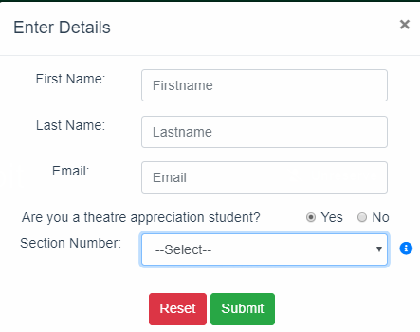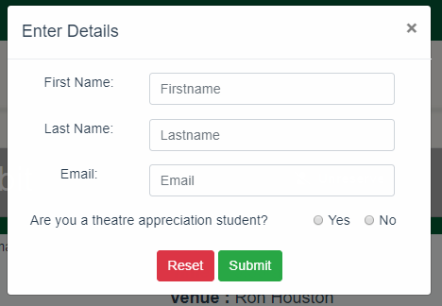

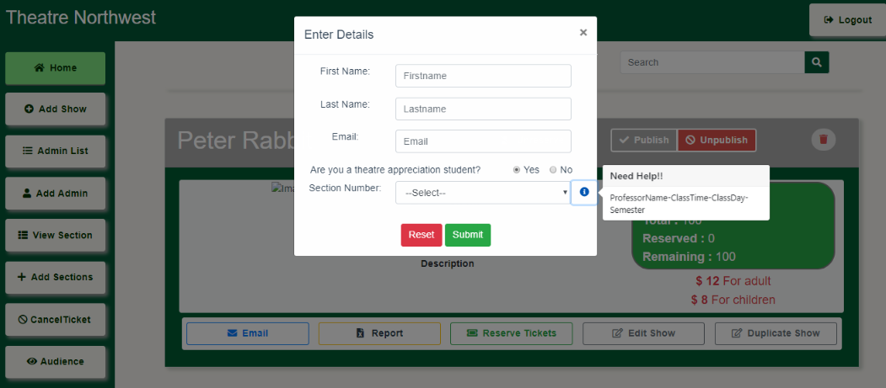

Figure 11.19

1. Admin can edit the show card by click on Edit button then a pop appears (figure 11.20)

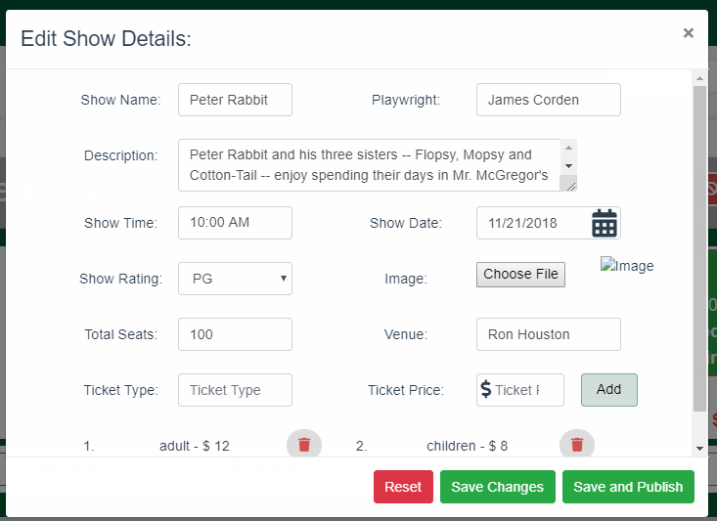

Figure 11.20

1. Once the admin clicks on Duplicate show button then a confirmation pop will appear then select Yes, sure button to complete the action (figure 11.21)

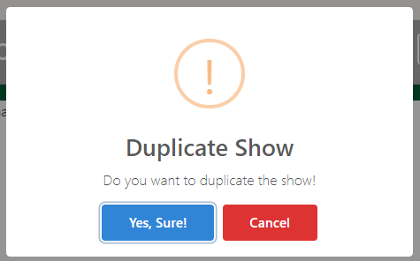

Figure 11.21

1. If admin wants to delete the show card, then a confirmation popup will appear. If admin selects Yes, delete it! button then selected show card will be deleted from the dashboard (figure 11.22)

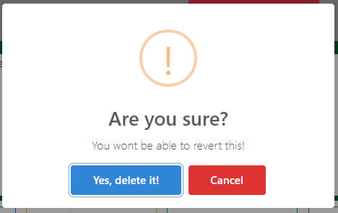

Figure 11.22

1. If admin selects unreserve then the page will navigate to corresponding show audience page (figure 11.23)

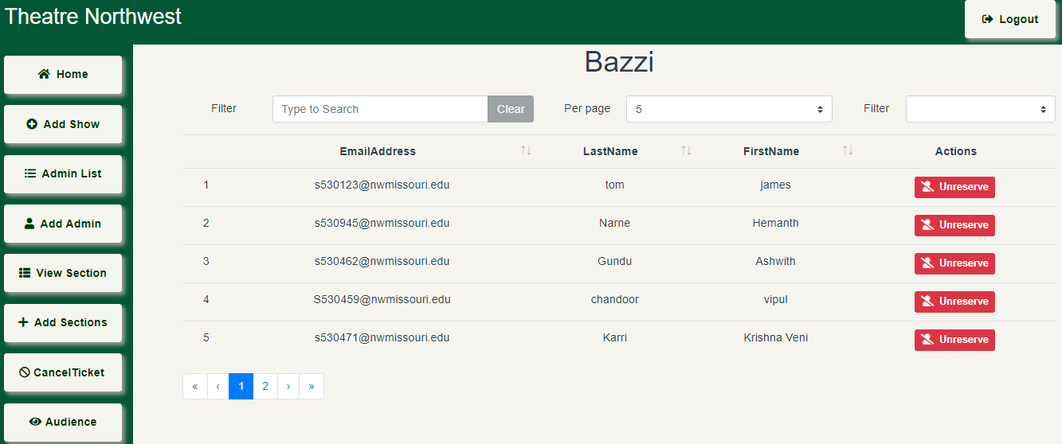

Figure 11.23

1. If we want to unreserve ticket for selected audience then click on the corresponding Unreserve button, then a confirmation popup will appear (figure 11.24)

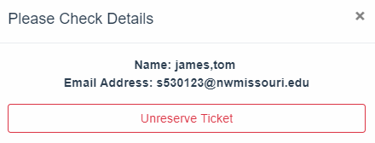

Figure 11.24

1. Again, on clicking on Unreserve Ticket button then an alert popup will appear with Success message (figure 11.25)

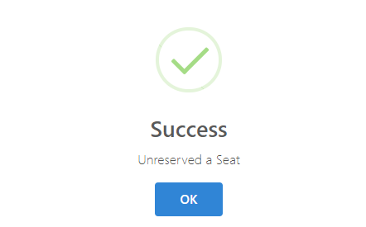

Figure 11.25